1. publisher/consumer

2. clusters

3. brokers

4. Topics

5. partitions

6. records

7. offsets

8. APIs, producer/consumer/source/sink/streams

9. Kafka downloads- opensource/confluent/confluent aws

10. wsl can be used, in windows docker desktop download up and running to run docker images, if want to run shell script in windows also install ubuntu and jdkm update apt if required.

Opensorce kafka to be downloaded from kafka website and confluent kafka free version from confluent website for community version.

Download offset explorer for kafka

Producing consuming messages:

1. Start zookeeper

**bin/zookeeper-server-start.sh config/zookeeper.properties**

1. Start kafka server on port 9092

**bin/kafka-server-start.sh config/server.properties**

1. Create topic

**bin/kafka-topics.sh --bootstrap-server localhost:9092 --create --topic my-topic --partitions 3 --replication-factor 1**

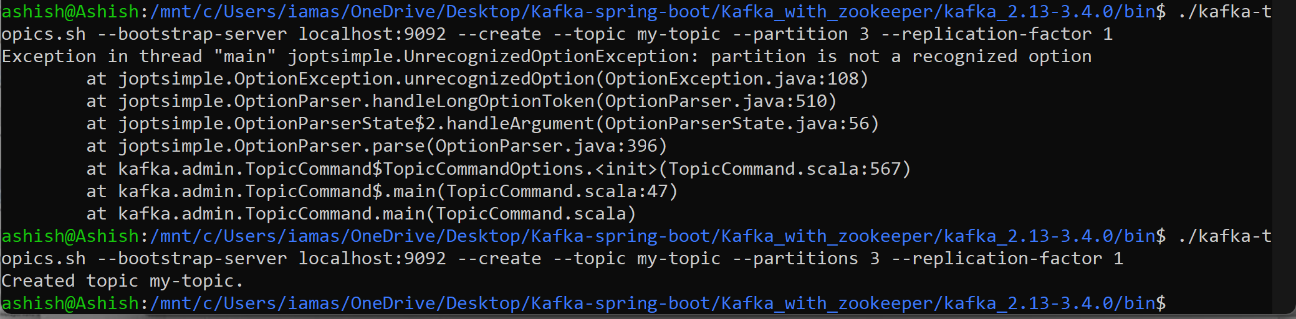

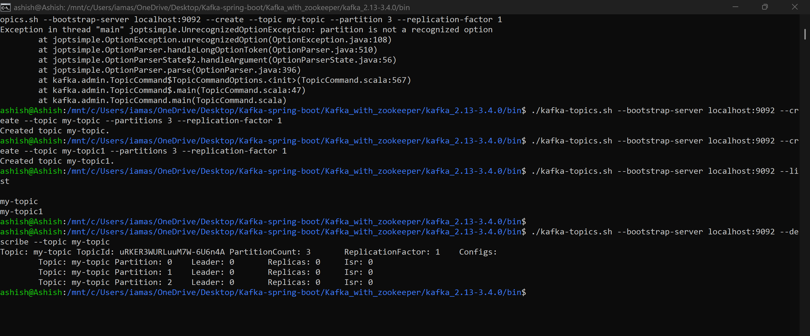

Can check in offset explorer.

Describe topic:  
**./kafka-topics.sh --bootstrap-server localhost:9092 --describe --topic my-topic**

Get all Topic in broker:

**./kafka-topics.sh --bootstrap-server localhost:9092 --list**

1. Start the producer now with script and cmd as:

Kafka-console-producer.sh

**./kafka-console-producer.sh --broker-list localhost:9092 --topic my-topic**

Listing all the available brokers, currently one and topic to publish msgs.

1. Start the consumer with script and cmd as:

./kafka-console-consumer.sh --bootstrap-server localhost:9092 --topic my-topic --from-beginning

broker-list is legacy syntax.  
bootstrap-server is the universal, modern way for all Kafka clients.

“Historically producers used broker-list and consumers used ZooKeeper. Modern Kafka unified both under bootstrap-server, which should be used everywhere.”

Zookeeper will take care of messages will go in which partition.

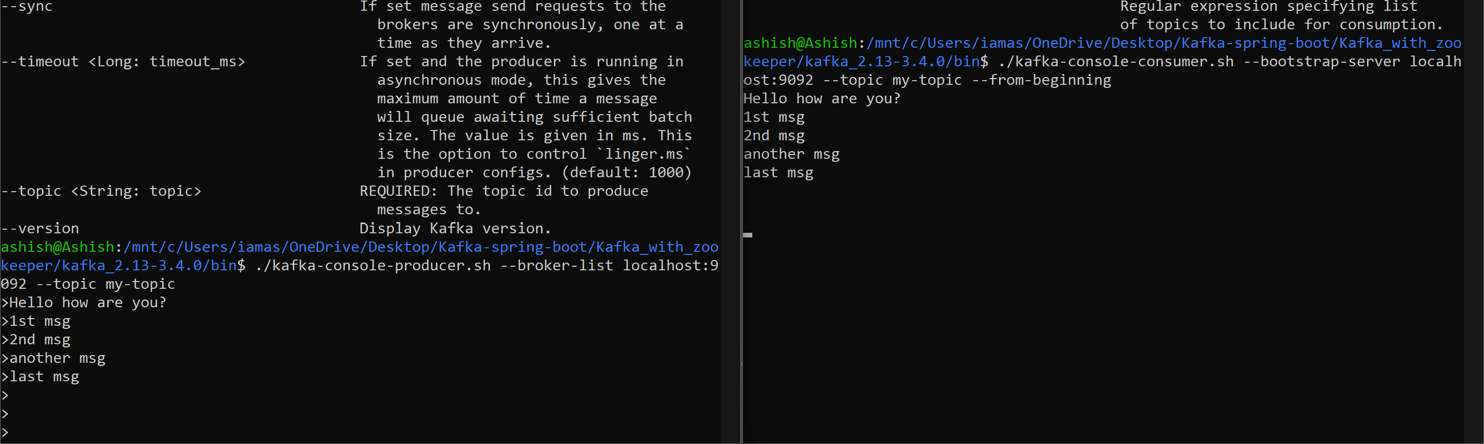

Giving a comma separated file to kafka producer:

**./kafka-console-producer.sh --broker-list localhost:9092 --topic my-topic <mnt/c/Users/iamas/OneDrive/Desktop/Kafka-spring-boot/employees.csv>**

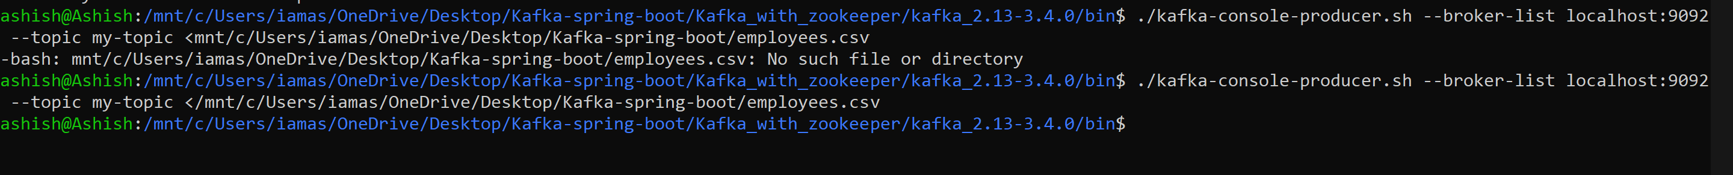

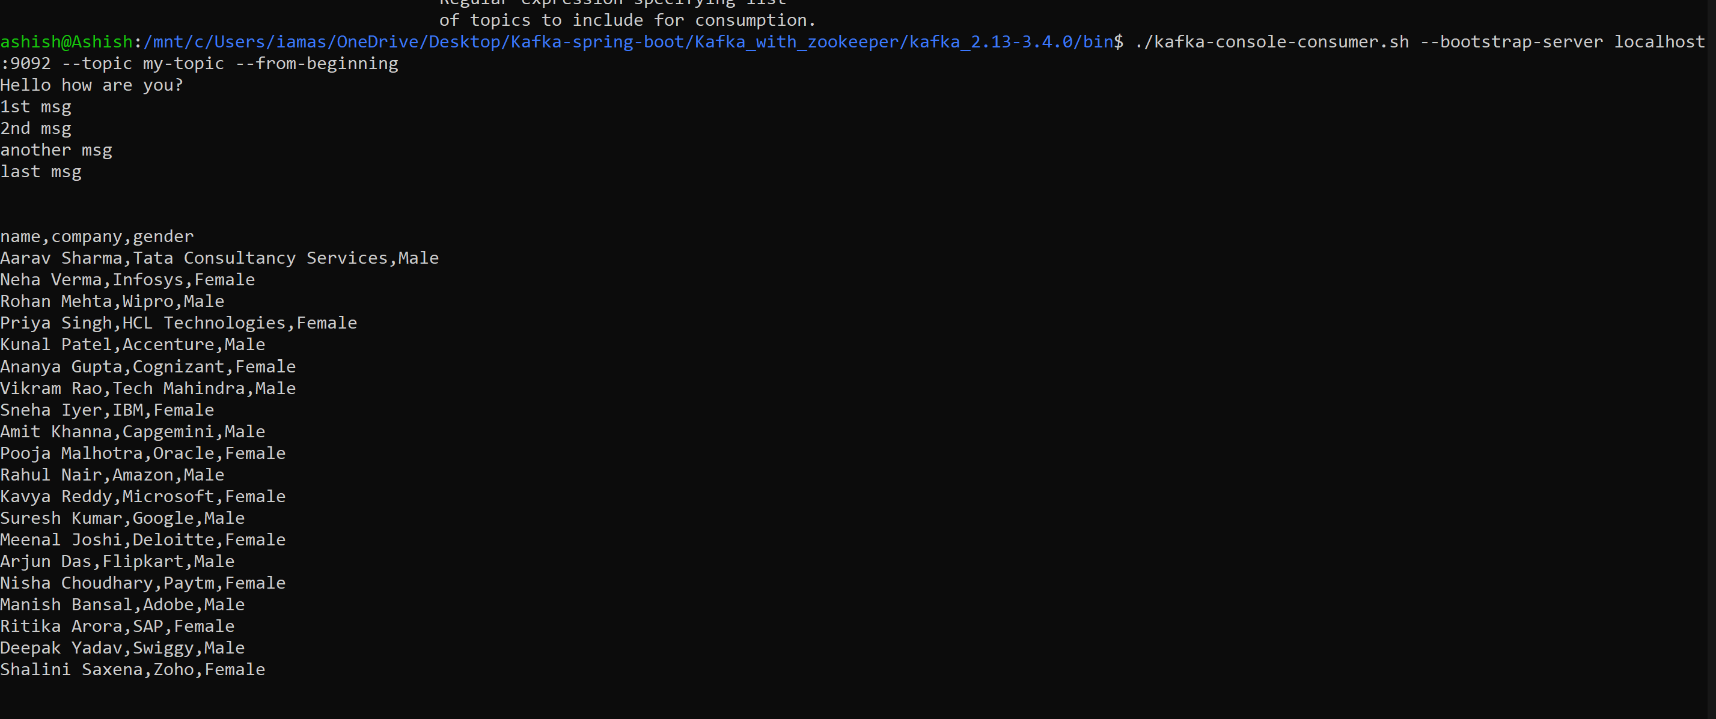

The above ones are done by wsl ubuntu, now I will use confluent kafka which has different directory structures but will use windows batch now instead of linux ones.

* Not able to run batch script in confluent kafka but able to do so in apache kafka, maybe some issues, when asked to chatGpt
* **Nobody uses Confluent Platform on native Windows for learning or prod.**
* They use:
* Linux
* Docker
* Kubernetes
* WSL
* Even Confluent internally develops on Linux/macOS.

C:\Users\iamas\OneDrive\Desktop\Kafka-spring-boot\Kafka_with_zookeeper\confluent-7.3.2\bin\windows\zookeeper-server-start.bat C:\Users\iamas\OneDrive\Desktop\Kafka-spring-boot\Kafka_with_zookeeper\confluent-7.3.2\etc\kafka\zookeeper.properties

Simplest way using docker:

Run docker desktop.

Run docker-compose file from intellij or from terminal as (**docker compose up**).

If to run specific docker file we have to use -f for file as:

**docker compose -f docker-compose.yml up**

version: '3.1'  
  
services:  
 zookeeper:  
 image: zookeeper  
 container_name: zookeeper  
 ports:  
 - "2181:2181"  
 kafka:  
 image: apache/kafka:4.1.1  
 container_name: kafka  
 ports:  
 - "9092:9092"  
 environment:  
 KAFKA_ADVERTISED_HOST_NAME: localhost  
 KAFKA_ZOOKEEPER_CONNECT: zookeeper:2181

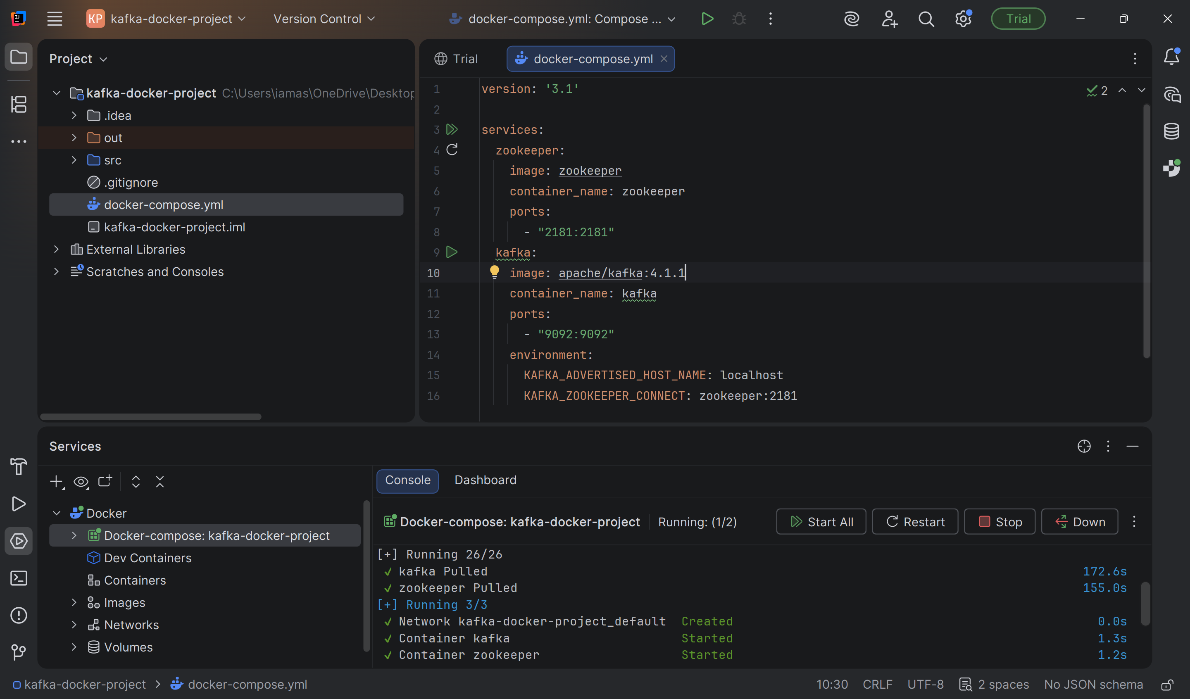

Docker images and docker ps commands:

**docker images**

**docker ps**

**docker ps -a** (all images even the ones that are terminated)

**docker logs kafka** (logs of kafka container)

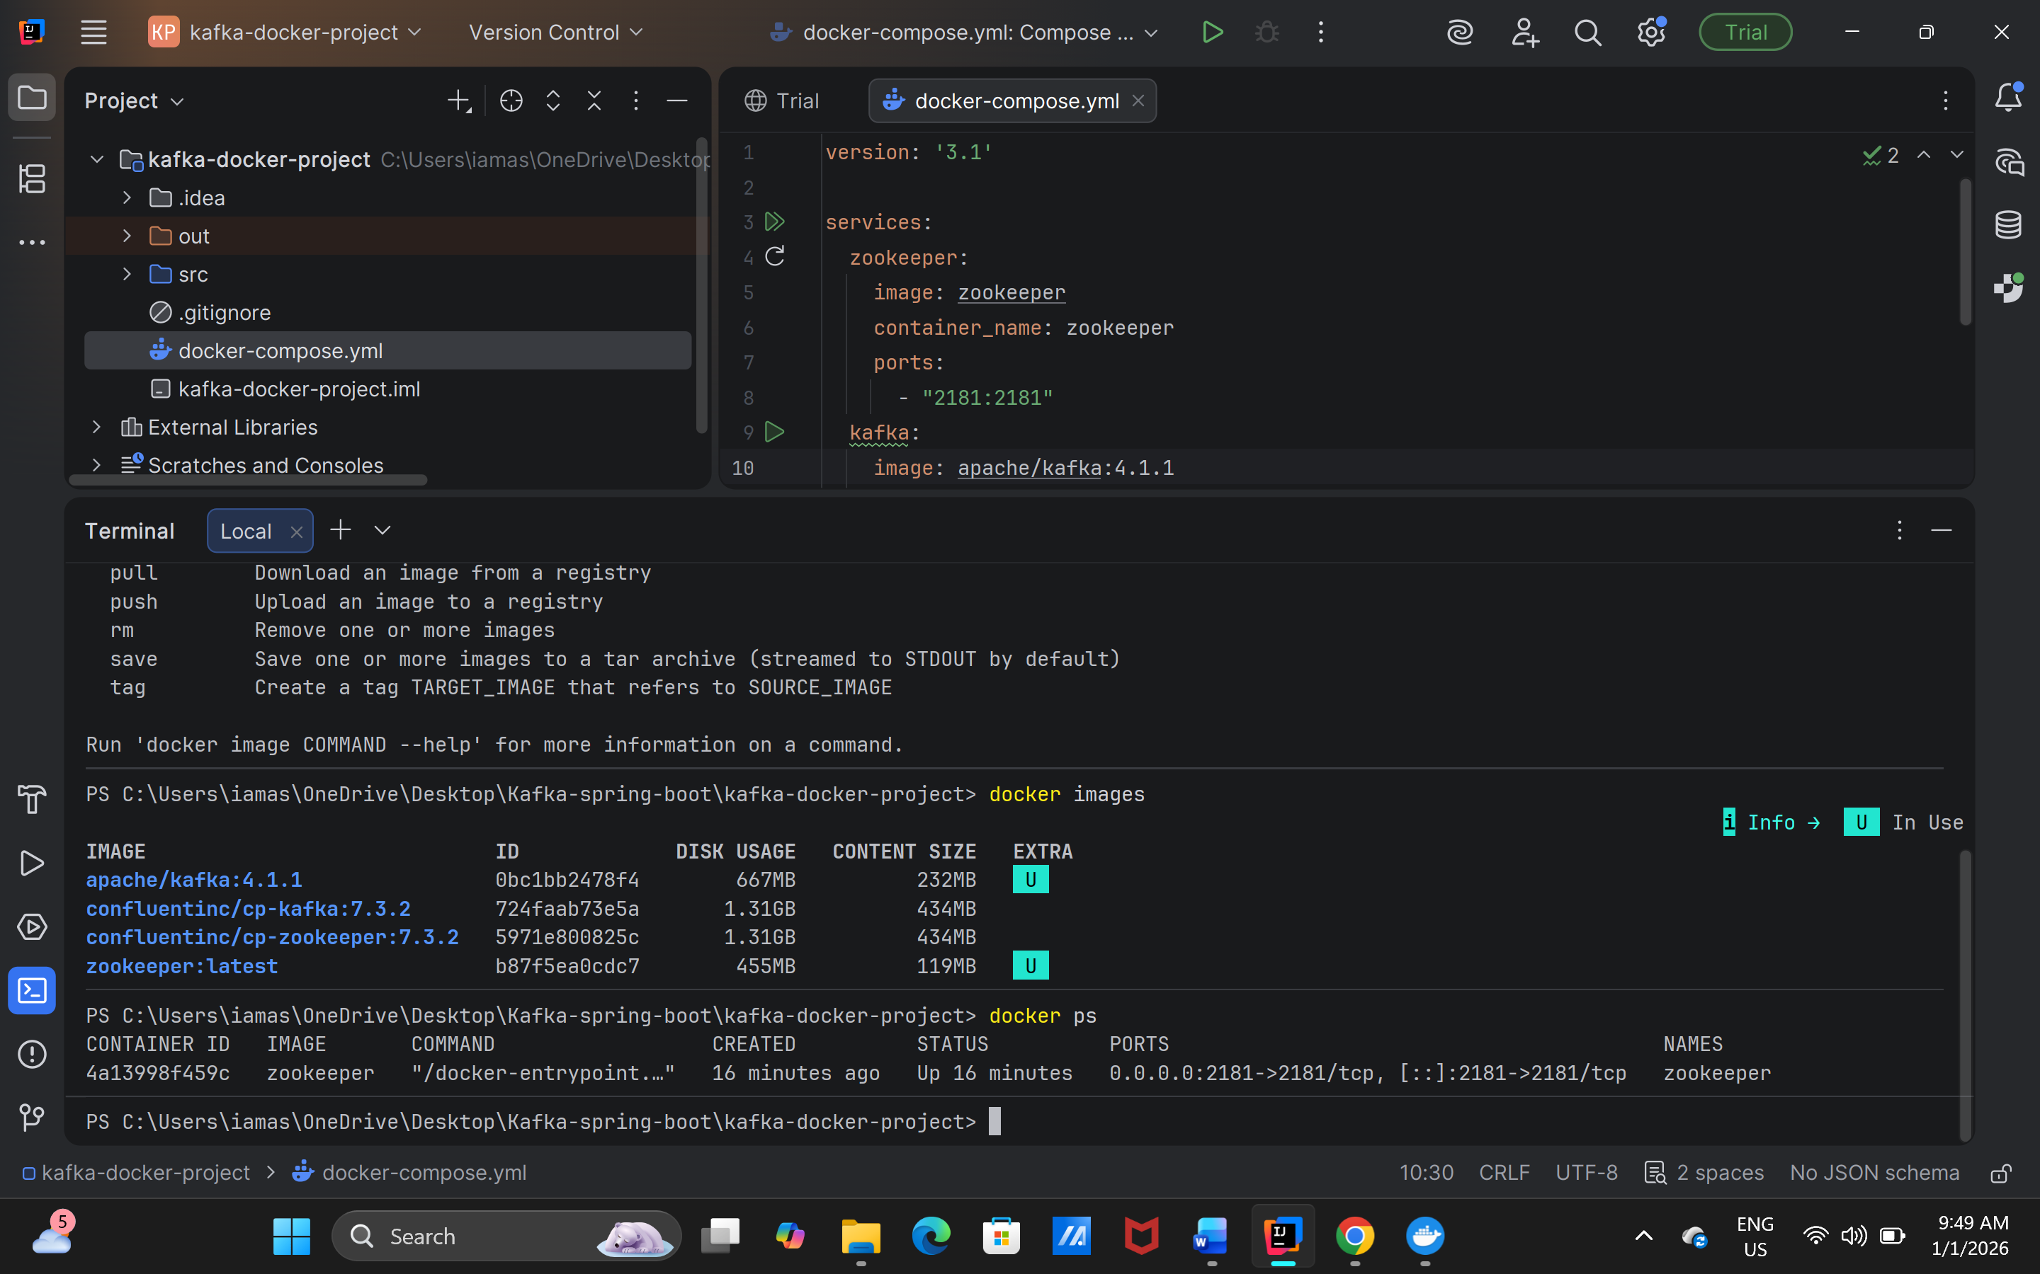

With kafka 4.1.1 which is currently latest may require the kraft(not sure), therefore downgrading to lower version of kafka: here is the error:

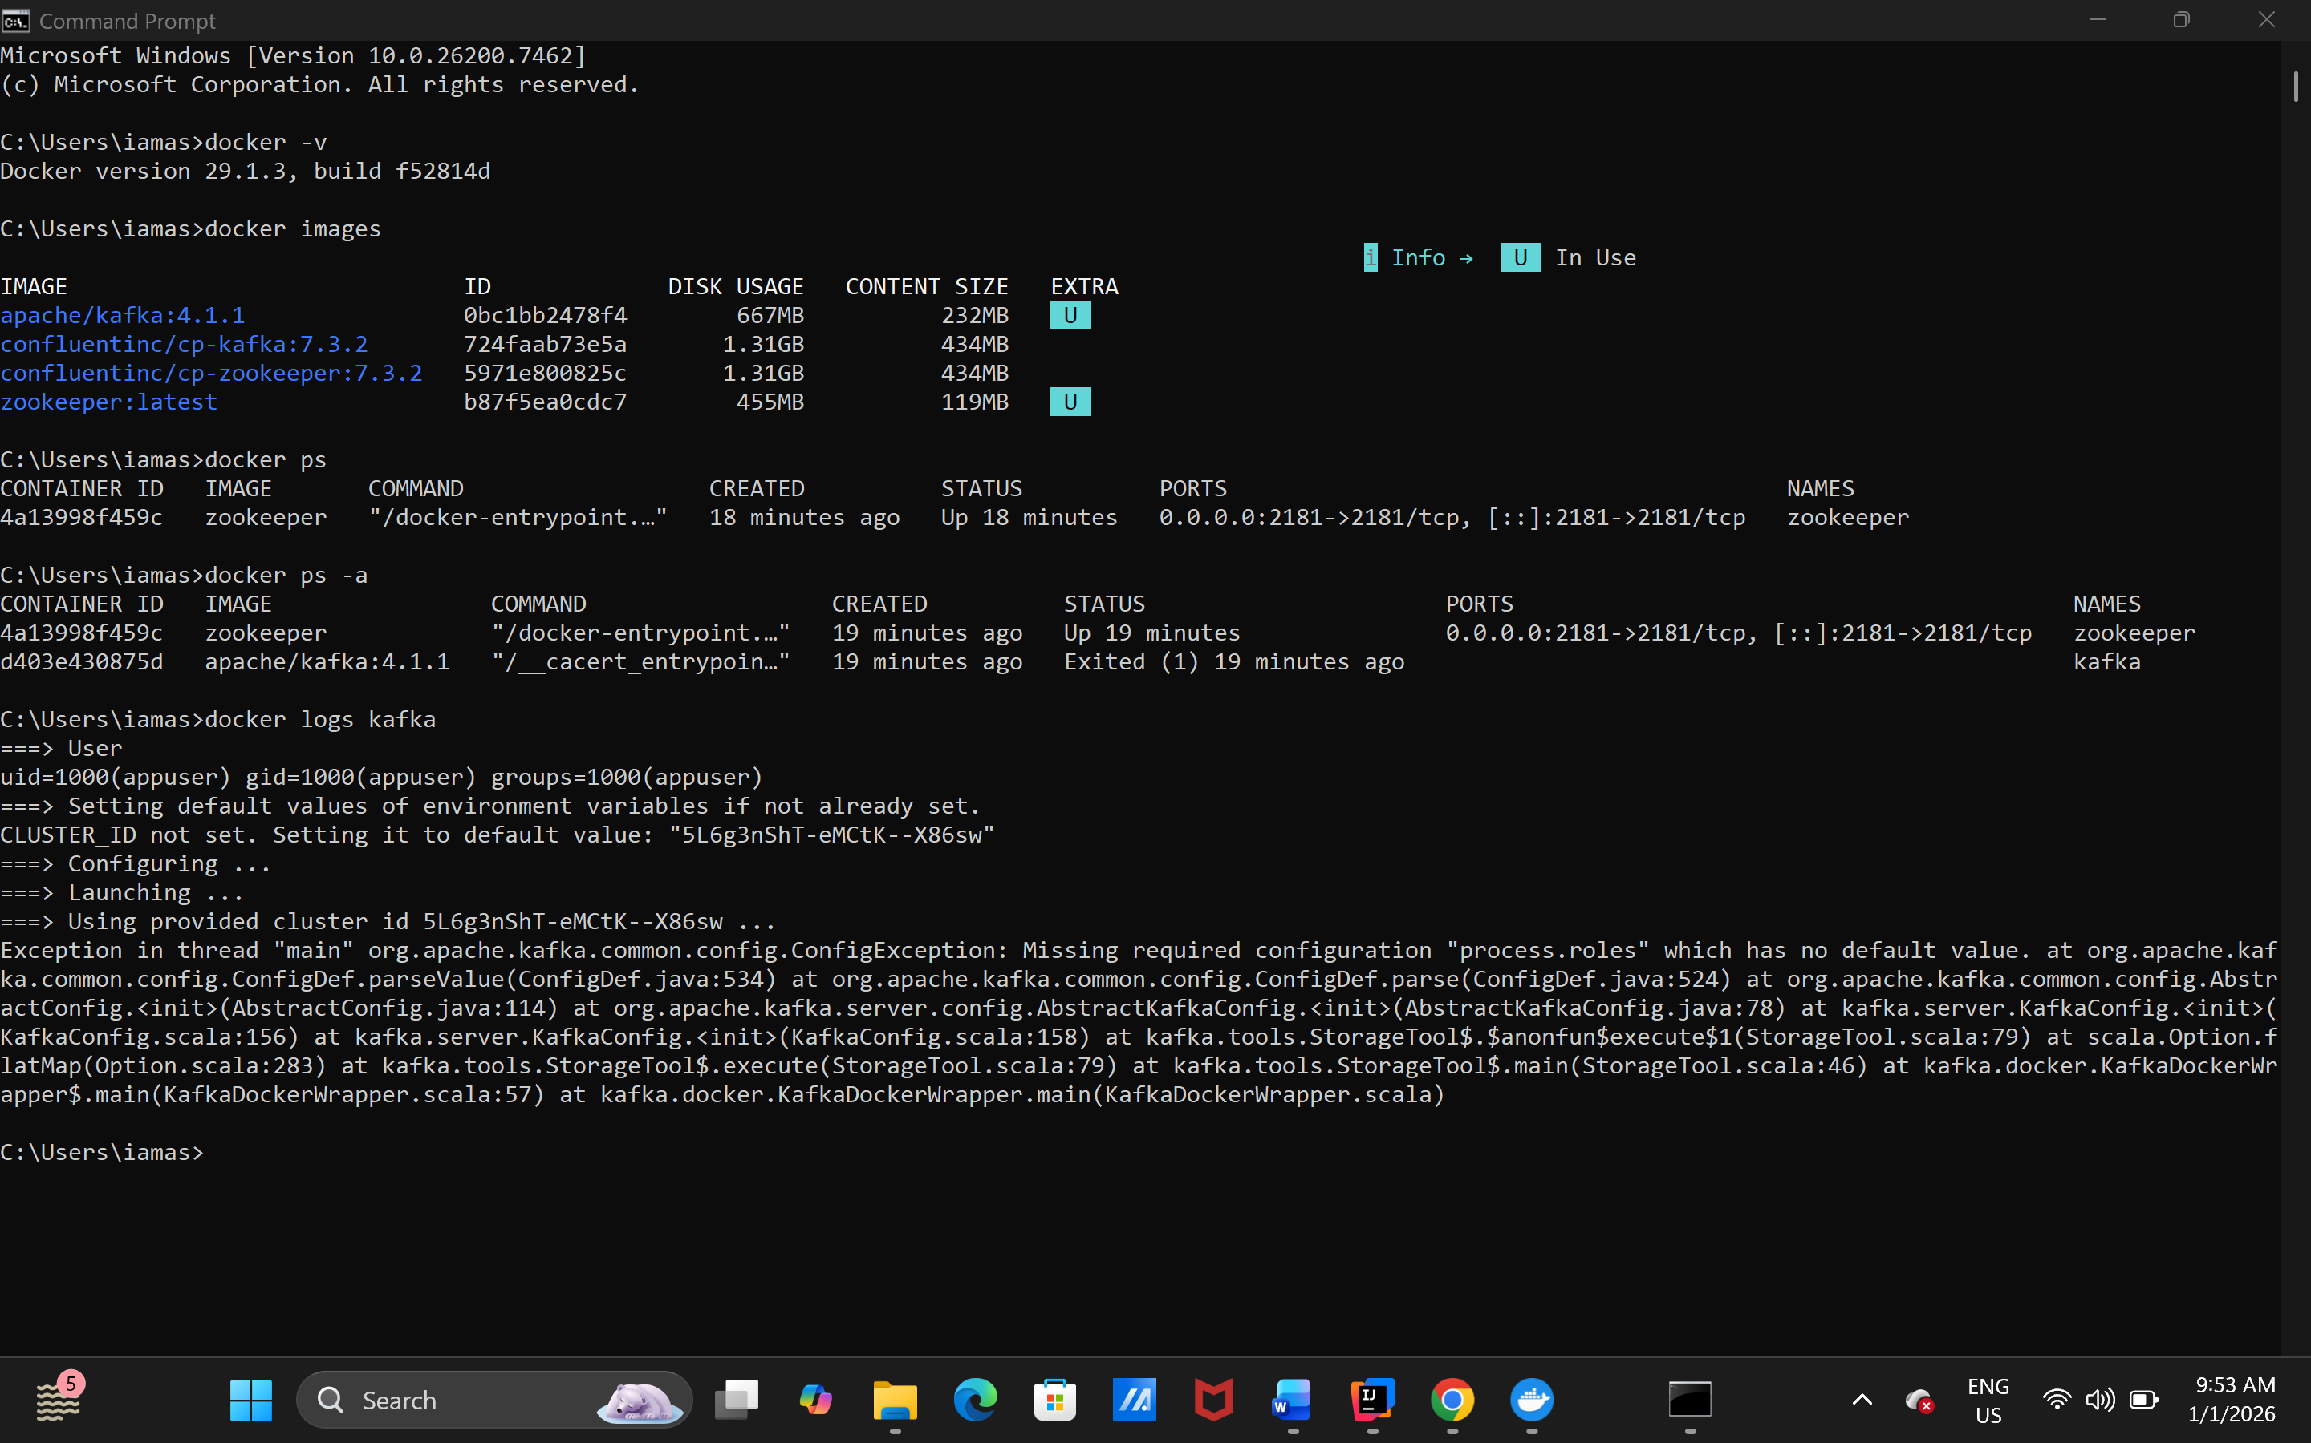

After downgrading:

Kept this config:

version: '3.1'  
  
services:  
 zookeeper:  
 image: wurstmeister/zookeeper  
 container_name: zookeeper  
 ports:  
 - "2181:2181"  
 kafka:  
 image: wurstmeister/kafka  
 container_name: kafka  
 ports:  
 - "9092:9092"  
 environment:  
 KAFKA_ADVERTISED_HOST_NAME: localhost  
 KAFKA_ZOOKEEPER_CONNECT: zookeeper:2181

Now to enter in kafka running container as:

**docker exec -it kafka bash**

go with opt/kafka_2.13-2.8.1/bin and can execute scripts.

To create topic as:

**./kafka-topics.sh --zookeeper zookeeper:2181 --create --topic quickstart --replication-factor 1 --partitions** **3**

# **MODERN VERSION (Correct)**

./kafka-topics.sh --bootstrap-server localhost:9092 --create --topic quickstart --replication-factor 1 --partitions 3

Better way:

**./kafka-topics.sh --bootstrap-server kafka:9092 --create --topic quickstart --replication-factor 1 --partitions 3**

**Or**

**./kafka-topics.sh --bootstrap-server localhost:9092 --create --topic quickstart3 --replication-factor 1 --partitions 3**

Starting producer.

**kafka-console-producer.sh --bootstrap-server localhost:9092 --topic quickstart**

starting comsumer

**kafka-console-consumer.sh --bootstrap-server localhost:9092 --topic quickstart --from-beginning**

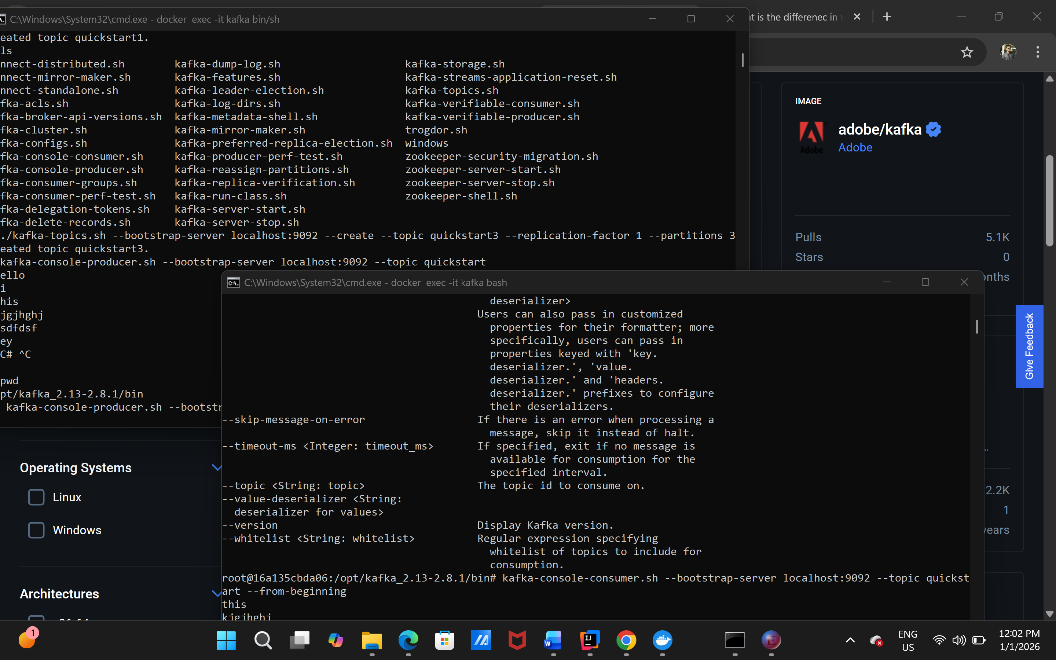

**Intellij kafka producer:**

**In application.properties should have:**

**spring.kafka.producer.bootstrap-servers=localhost:9092**

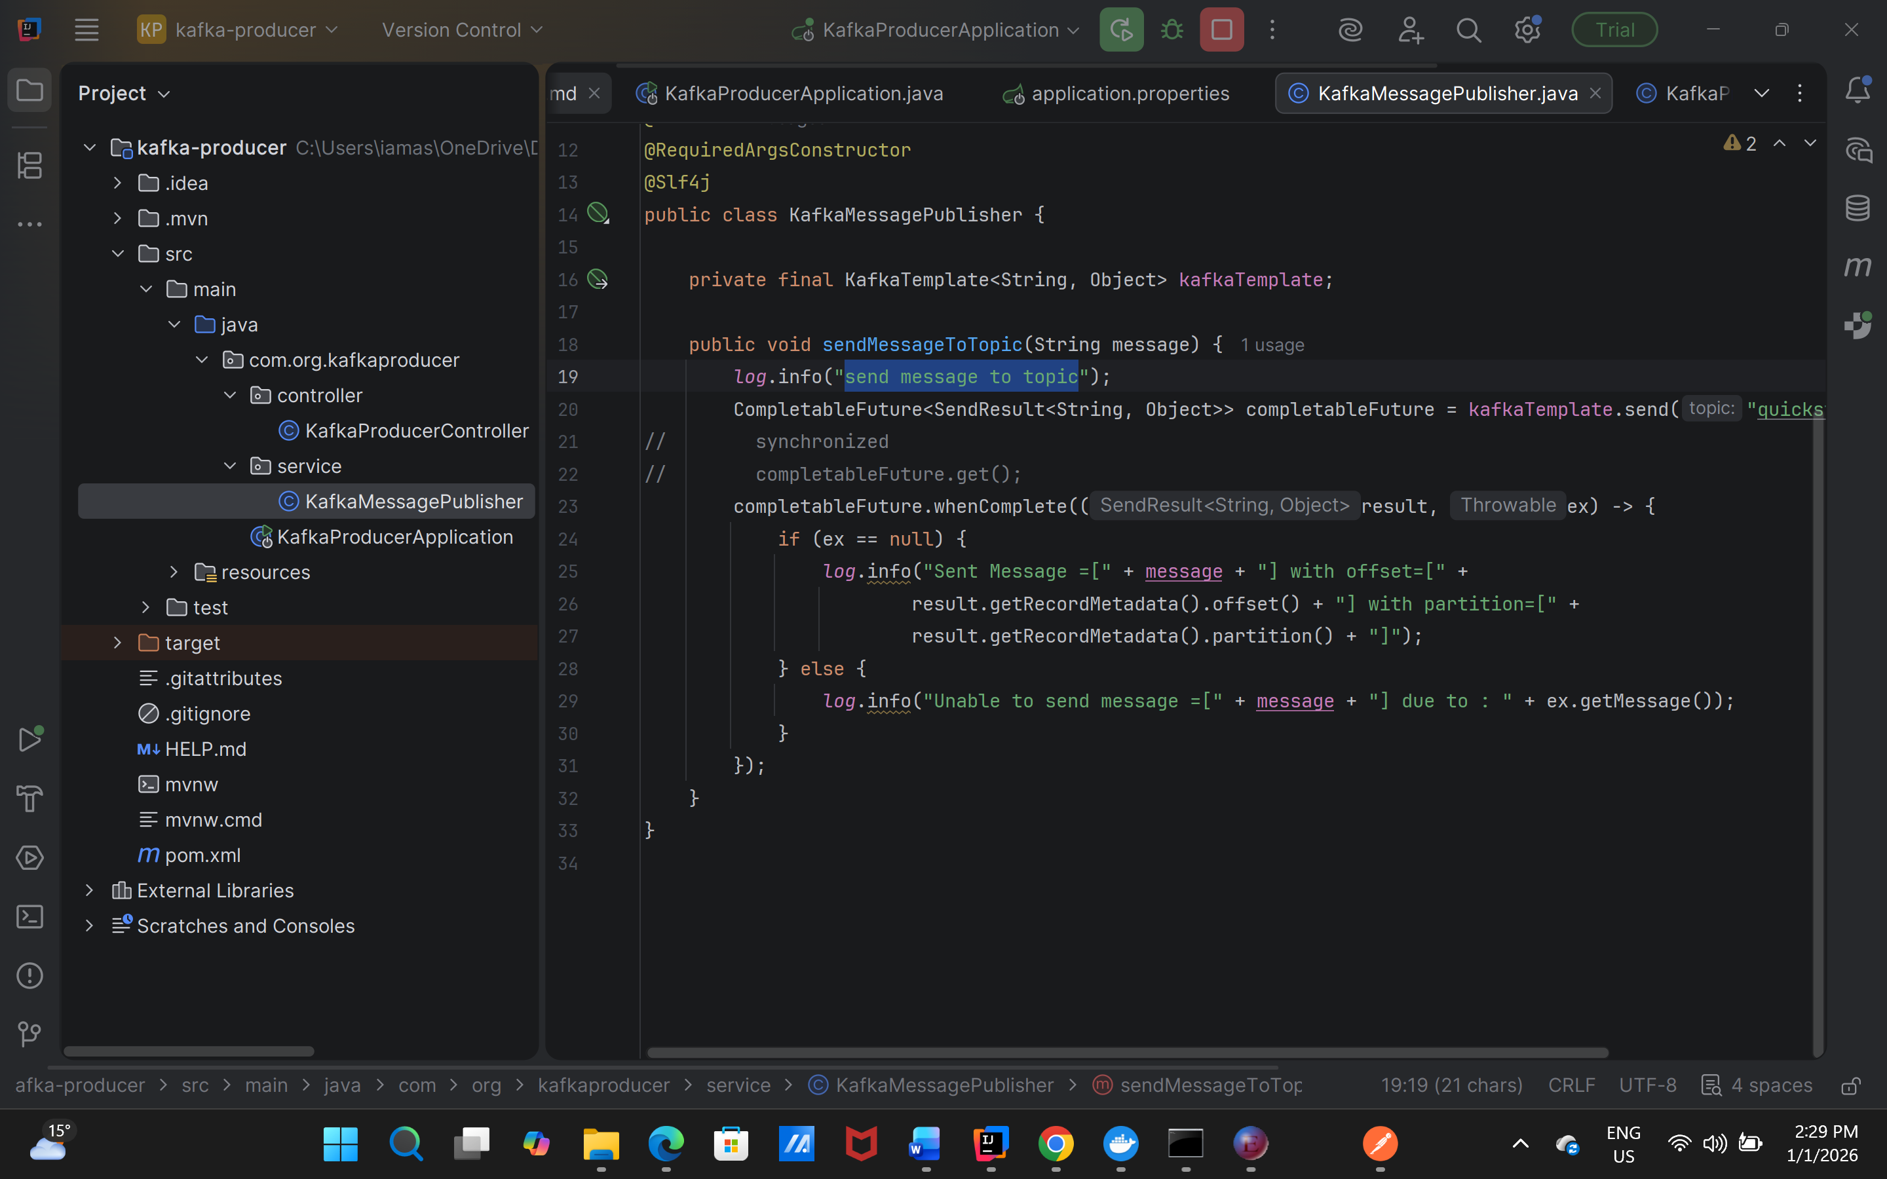

**Topic creation can be done from configs as well:**

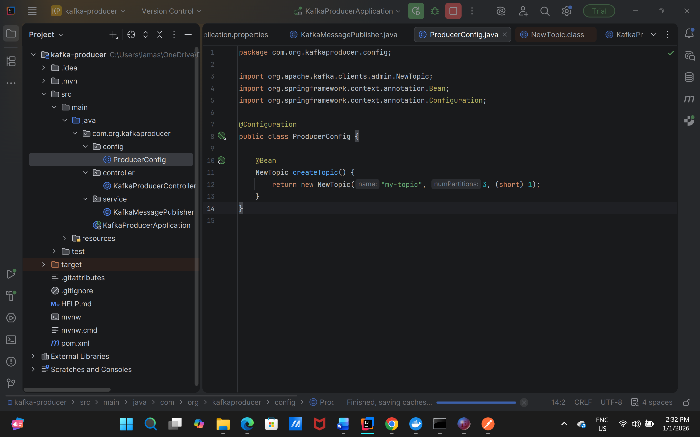

**Intellij kafka consumer**

**In application.properties should have:**

**spring.kafka.consumer.bootstrap-servers=localhost:9092**

**even we have one consumer still we have to put property for consumer group as:**

**spring.kafka.consumer.group-id=consumer-group1**

**to consume message @KafkaListener annotation to use and the method will be as:**

**@org.springframework.kafka.annotation.KafkaListener(topics = "my-topic2", groupId = "consumer-group1")  
public void consume(String message){  
 *log*.info("consumer consume the message {}", message);  
}**

**For parallel consuming of messages have to provide multiple consumers in consumer group.**

**One not preferable approach but for testing and understanding as creating two methods with kafka listener listening to same topic and having groupid similar.**

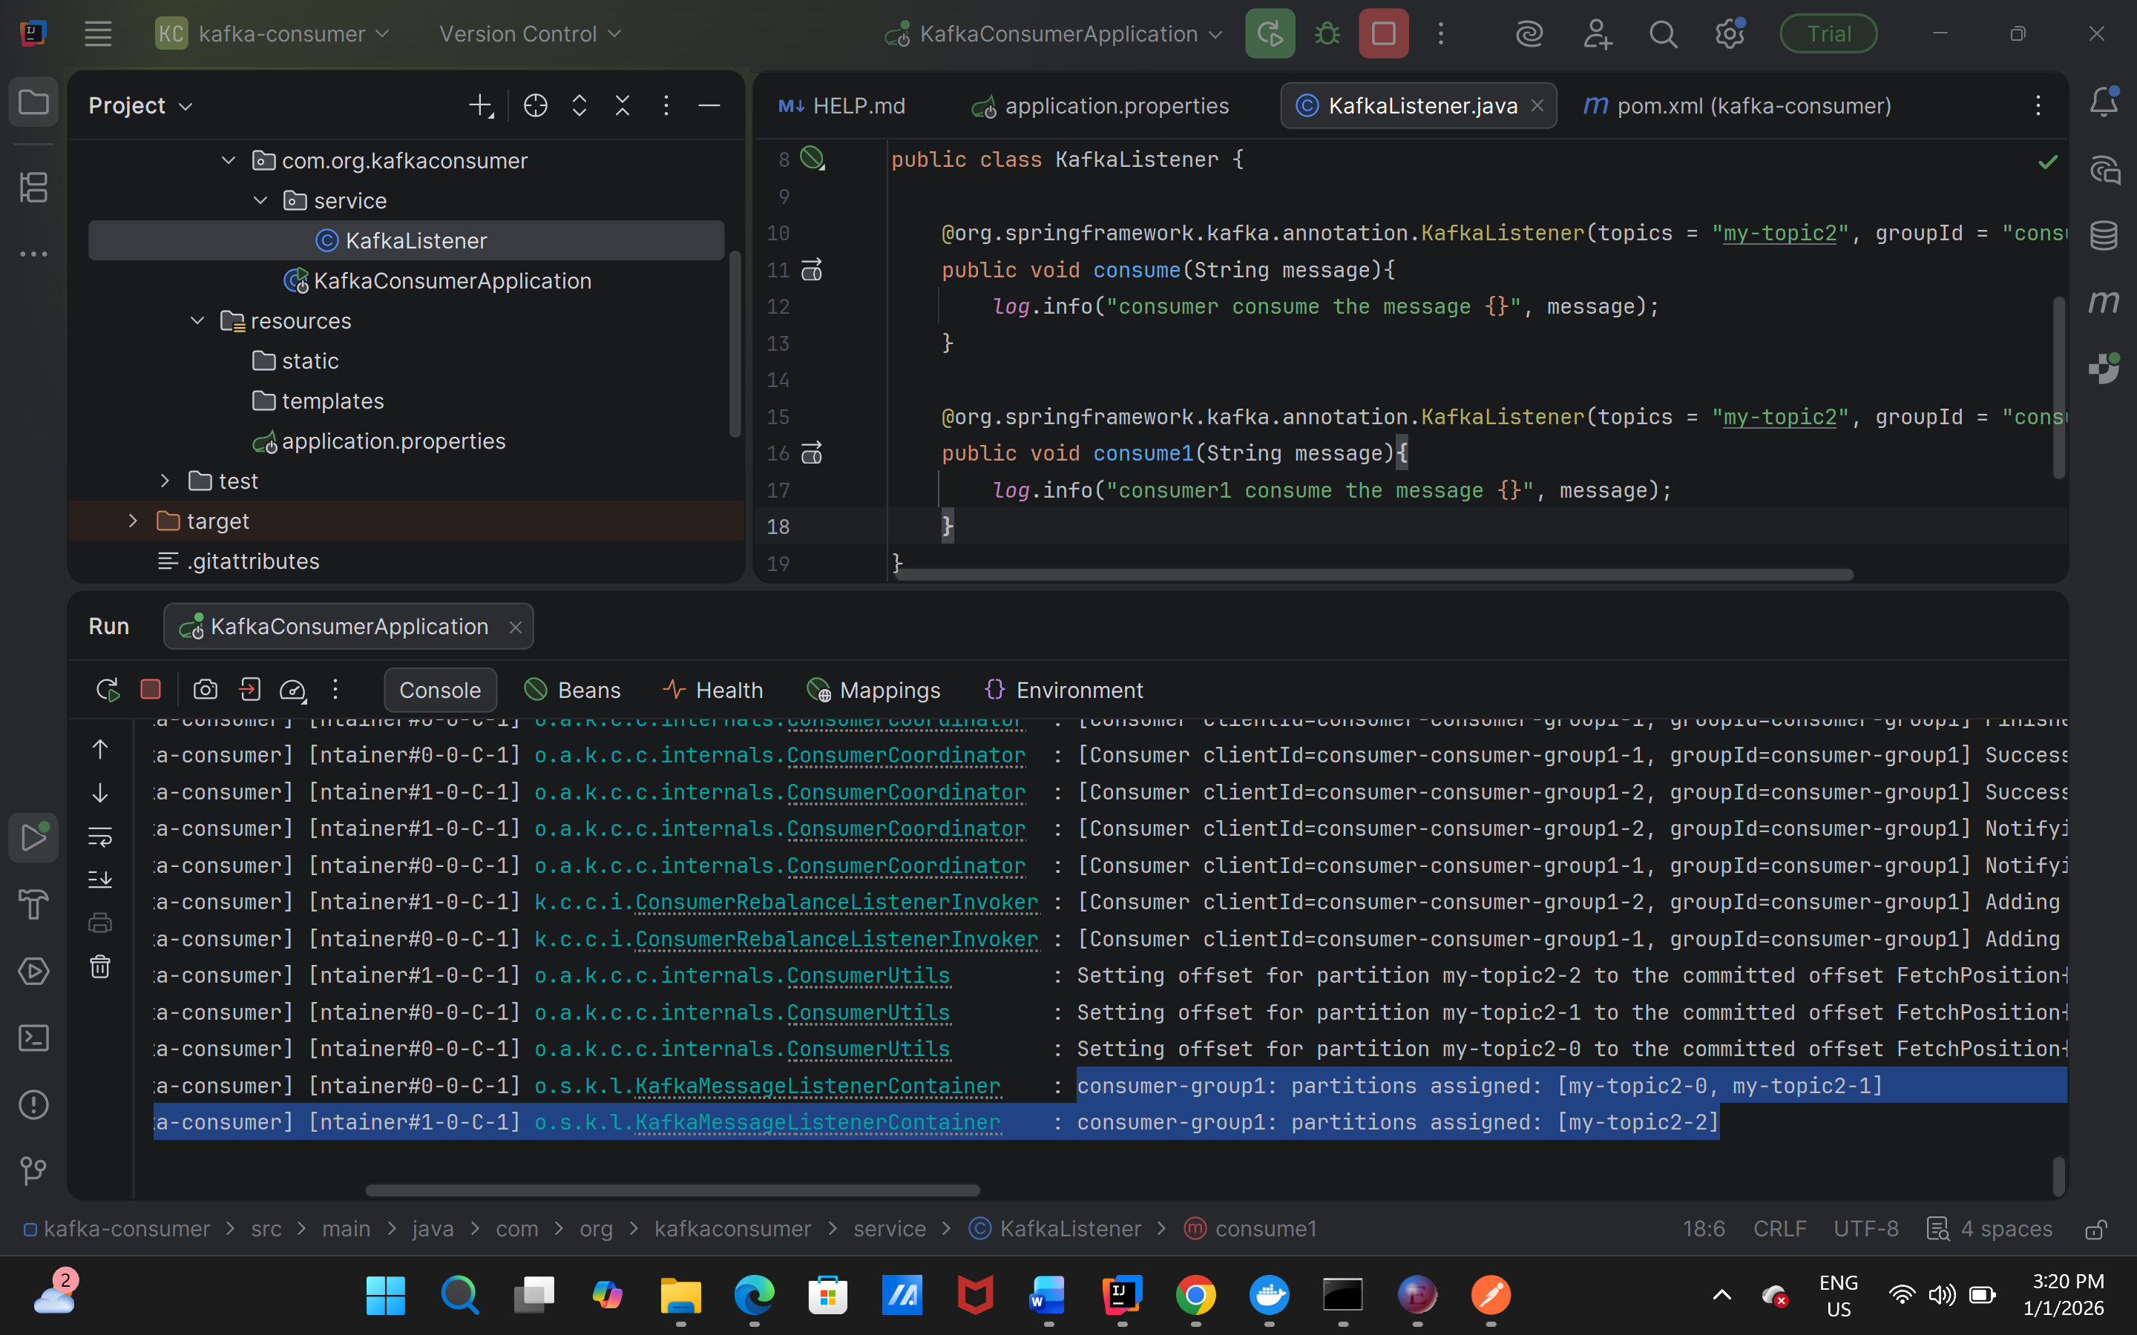

**Here the two partitions of topic my-topic2 are assigned to one consumer and 3rd partition is assigned to second consumer.**

**We can have consumer count similar to partition count to consume messages, and even more consumers than partitions as well, in that scenario one extra consumers will be on standby.**

**Serialization/Deserialization**

Default serialization/deserialization is in byte array.

When we are sending object types it gives error on serialization so we have to explicitly tell kafka to use a particular serializer/deserializer

The errro we get without using any explicit serializer as: 2026-01-01T16:09:44.322+05:30 INFO 30696 --- [kafka-producer] [nio-8080-exec-3] c.o.k.c.KafkaProducerController : exception is :Can't convert value of class com.org.kafkaproducer.model.Customer to class org.apache.kafka.common.serialization.StringSerializer specified in value.serializer

**Use serialization property from producer end as:**

**# Key Serializer (Standard String)  
spring.kafka.producer.key-serializer=org.apache.kafka.common.serialization.StringSerializer  
# Value Serializer (JSON)  
spring.kafka.producer.value-serializer=org.springframework.kafka.support.serializer.JsonSerializer**

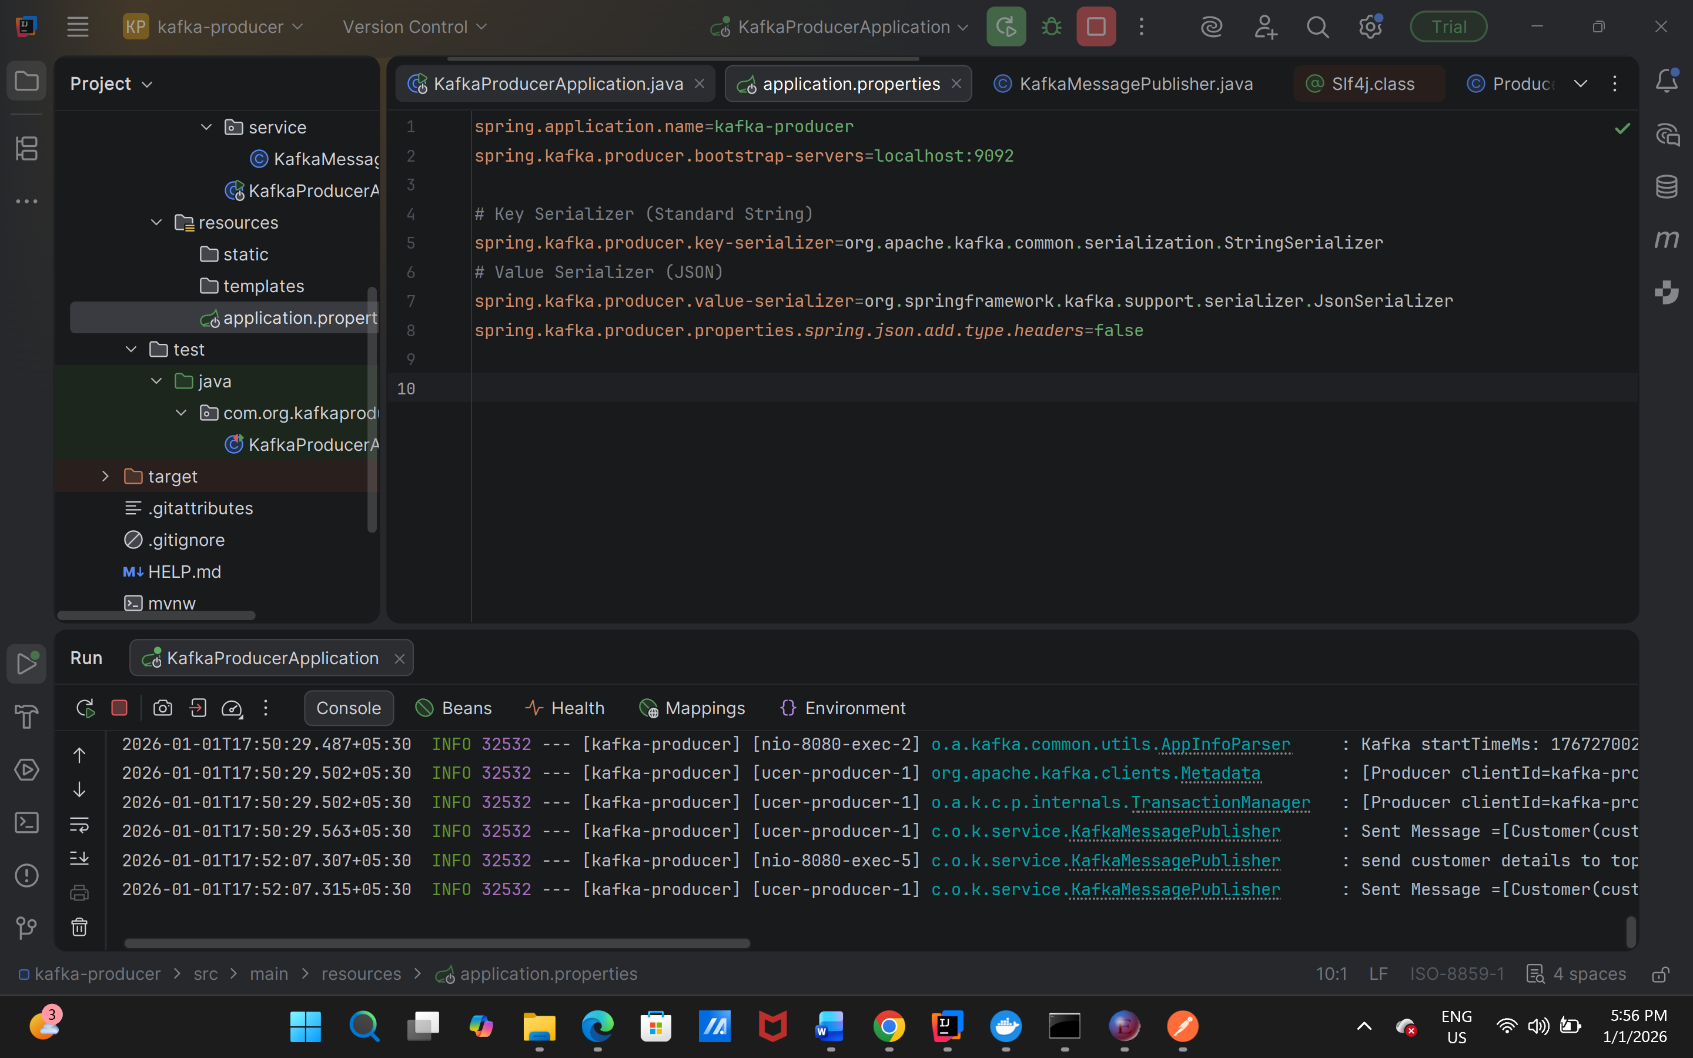

**Use Deserialization properties from consumer end as:**

**spring.kafka.consumer.key-deserializer=org.apache.kafka.common.serialization.StringDeserializer  
spring.kafka.consumer.value-deserializer=org.springframework.kafka.support.serializer.JsonDeserializer  
spring.kafka.consumer.properties.spring.json.trusted.packages=\***

**\* means all here, have to give specific model name along with package to allow.**

**Because kafka internally uses:**

**KEY | VALUE (bytes) | HEADERS**

**During serialization and desrialization headers TypeId is read.**

**KEY = null**

**VALUE = {"id":"1","name":"John"}**

**HEADERS = {**

**__TypeId__ : "com.org.kafkaproducer.model.Customer"**

**}**

**JsonSerializer (adds type headers)**

**JsonDeserializer (reads type headers)**

**kafka does not know Java  
Kafka only stores bytes + headers  
Spring Kafka decides what headers mean**

**Ideally the package should be similar for the model in both producer and consumer side, but if not in the same package structure then have to add the properties on consumer side to work otherwise error will be thrown.**

**The properties are as:**

**spring.kafka.consumer.properties.spring.json.use.type.headers=false  
spring.kafka.consumer.properties.spring.json.value.default.type=com.org.kafkaconsumer.model.Customer**

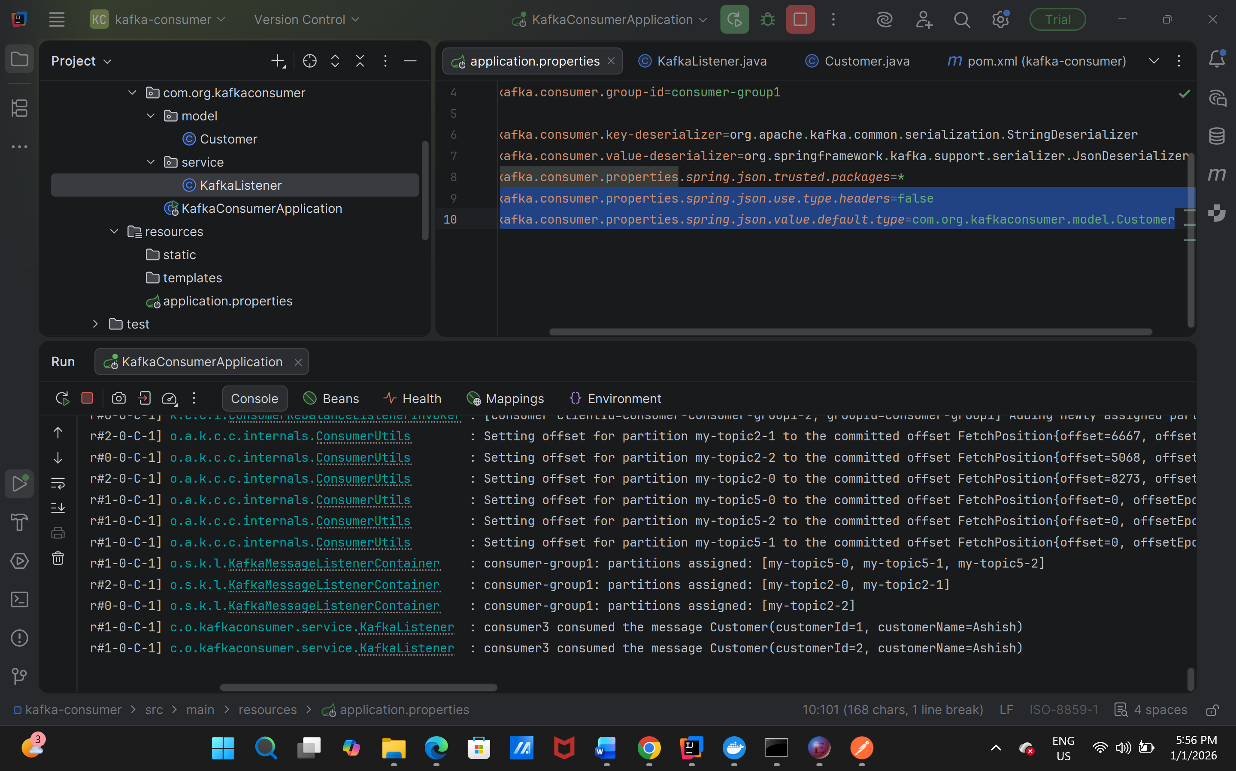

**So the configuration which was done in application.properties can be done via config as:**

**Kafka producer commented props:**

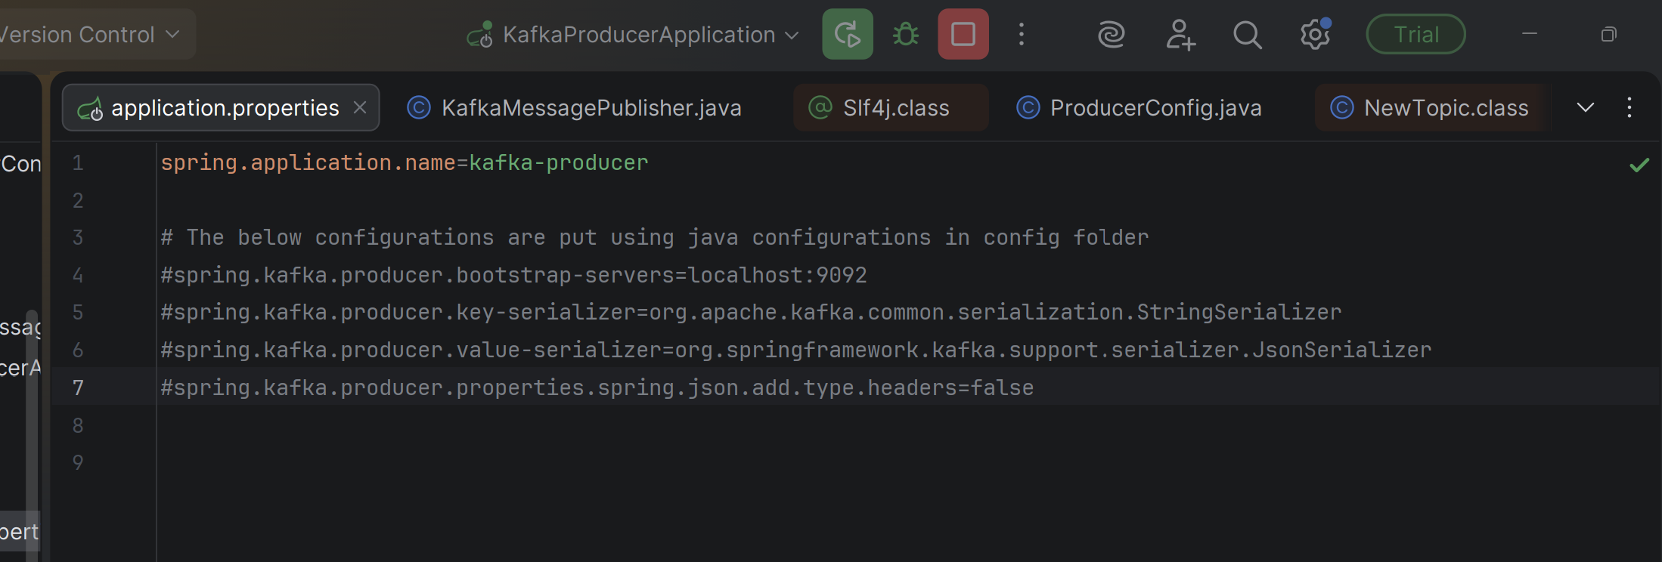

**Java configs as:**

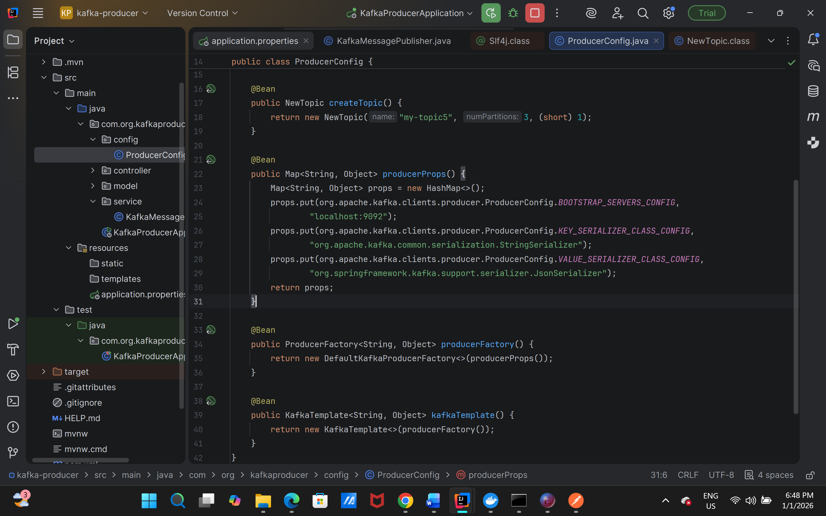

**For consumer as well:**

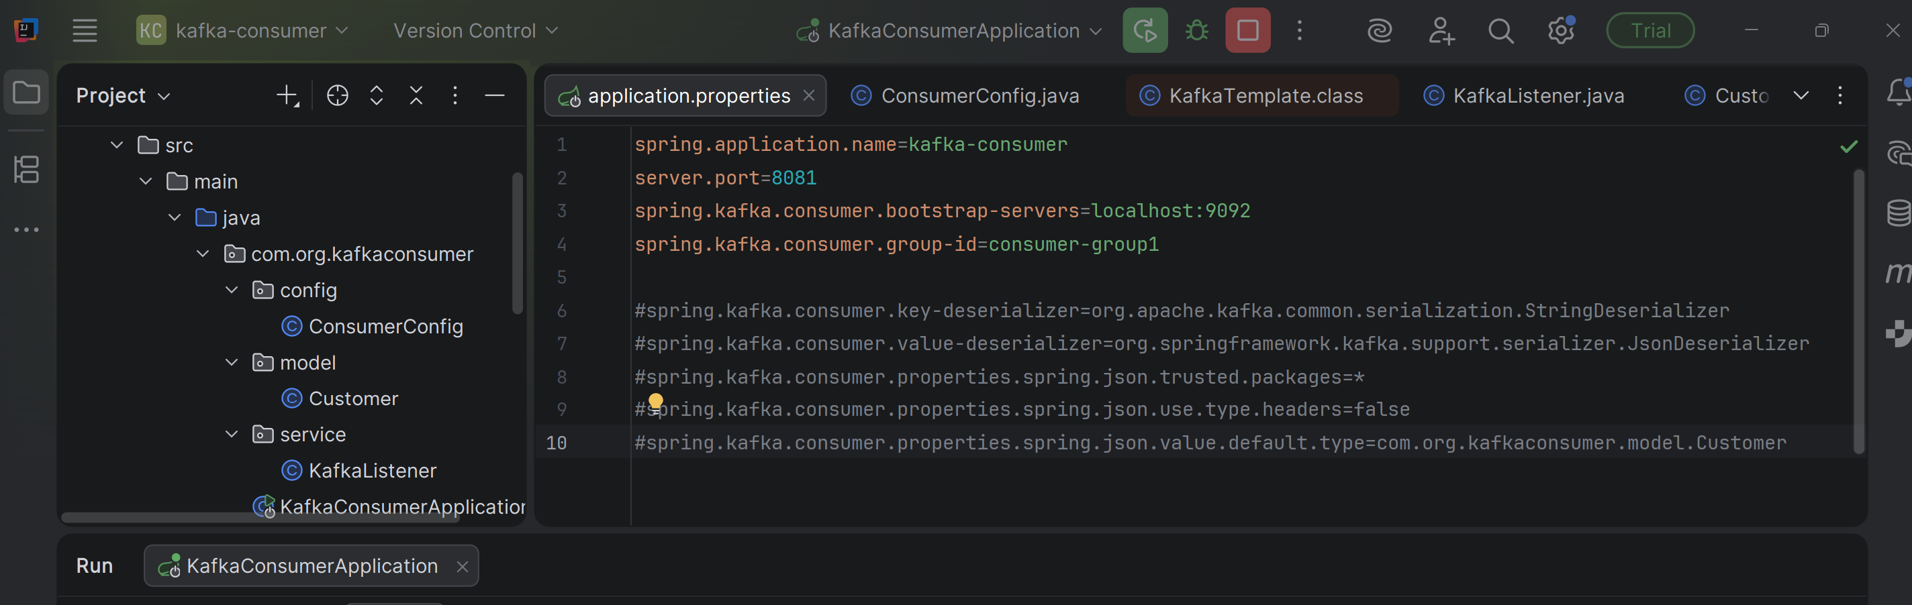

**Java configs:**

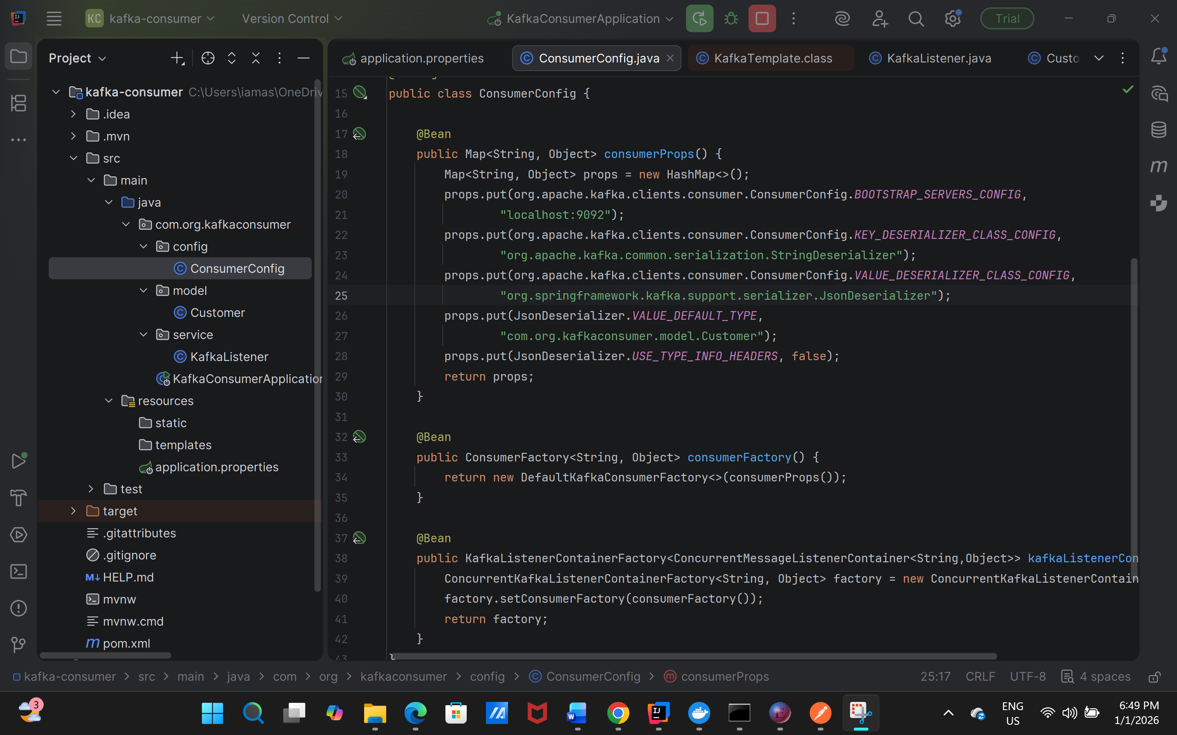

**Producing and consuming messages from specific partition:**

**Mentioning the partition name while producing:**

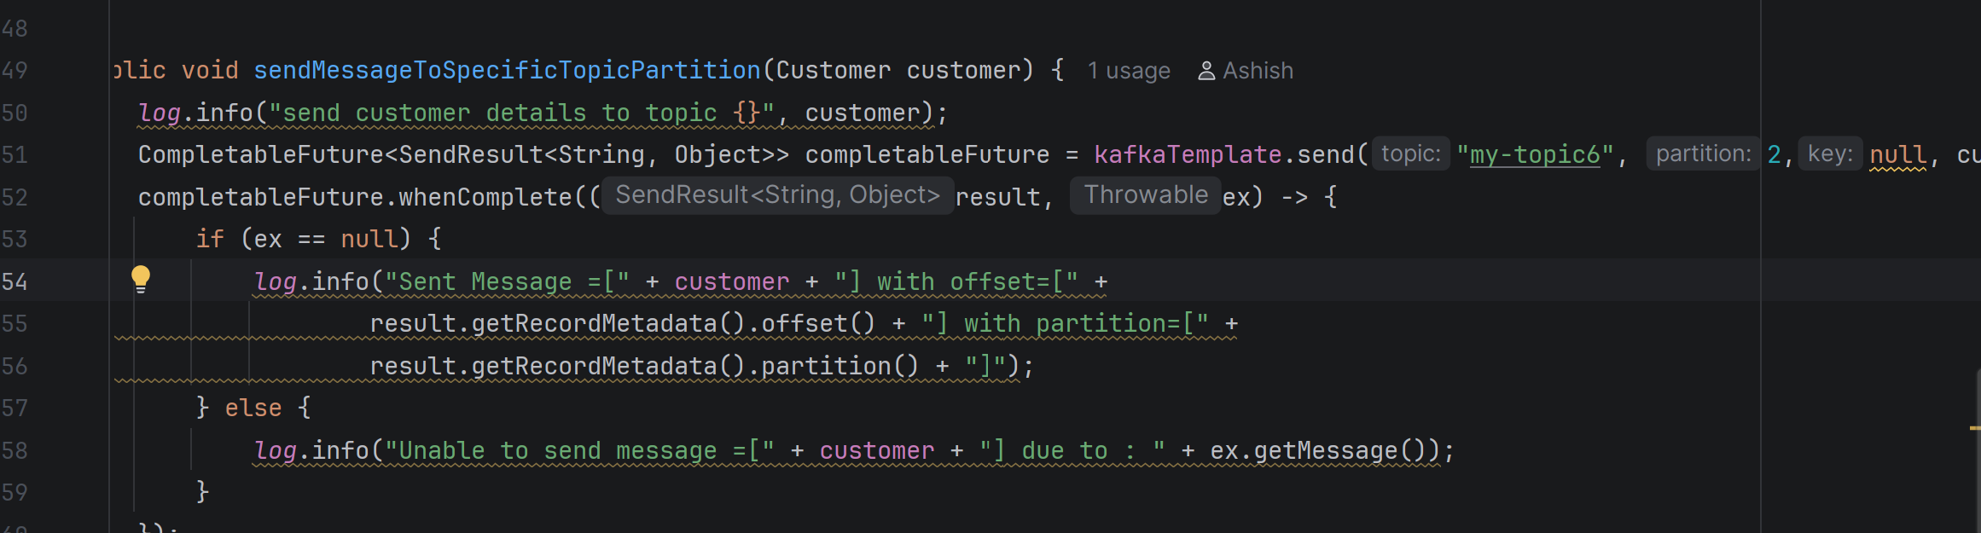

**Consuming from specific partition:**

**Annotation based as:**

**topicPartitions = {@TopicPartition(  
 topic = "my-topic6",  
 partitions = {"2"}**

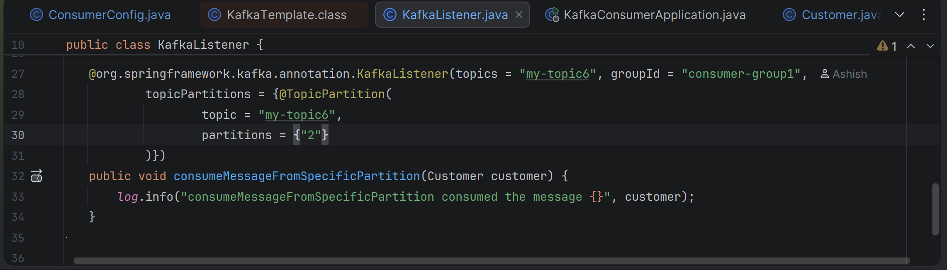

**Error Handling in Kafka:**

**Retry and DLT (Dead Letter Topic) in Kafka:**

**While consuming the messages retry will be done, after the attempts if it doesn’t succeed the message will move to dlt.**

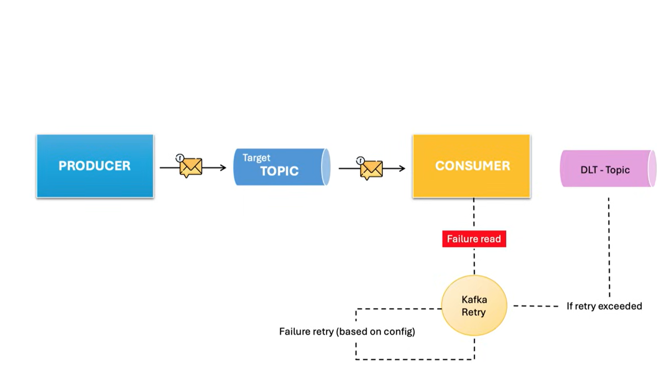

**Code example:**

**On consumer side to add**

**Retryable and @DltHandler**

**Value on retry attempt is N-1, if specified 4 means retry will happen 3.**

**\*\*\* As after retry the message will be published to dlt topic created automatically, therefore from consumer app should also have producer configs for kafka template with overridden serializers.**

Also retry topic are also created. The no. of times retry fails the no of times the data is sent to retry topic if it still fails after attempts then sent to dlt topic.

One retry topic and one dlt topic will be created, in certain spring boot version or lower versions depending upon retry attempts the retry topics were created. Even if we use attempts with backoff delays we will get multiple retry topics as well.

We can exclude certain exceptions using exclude keywork within retryable annotations.

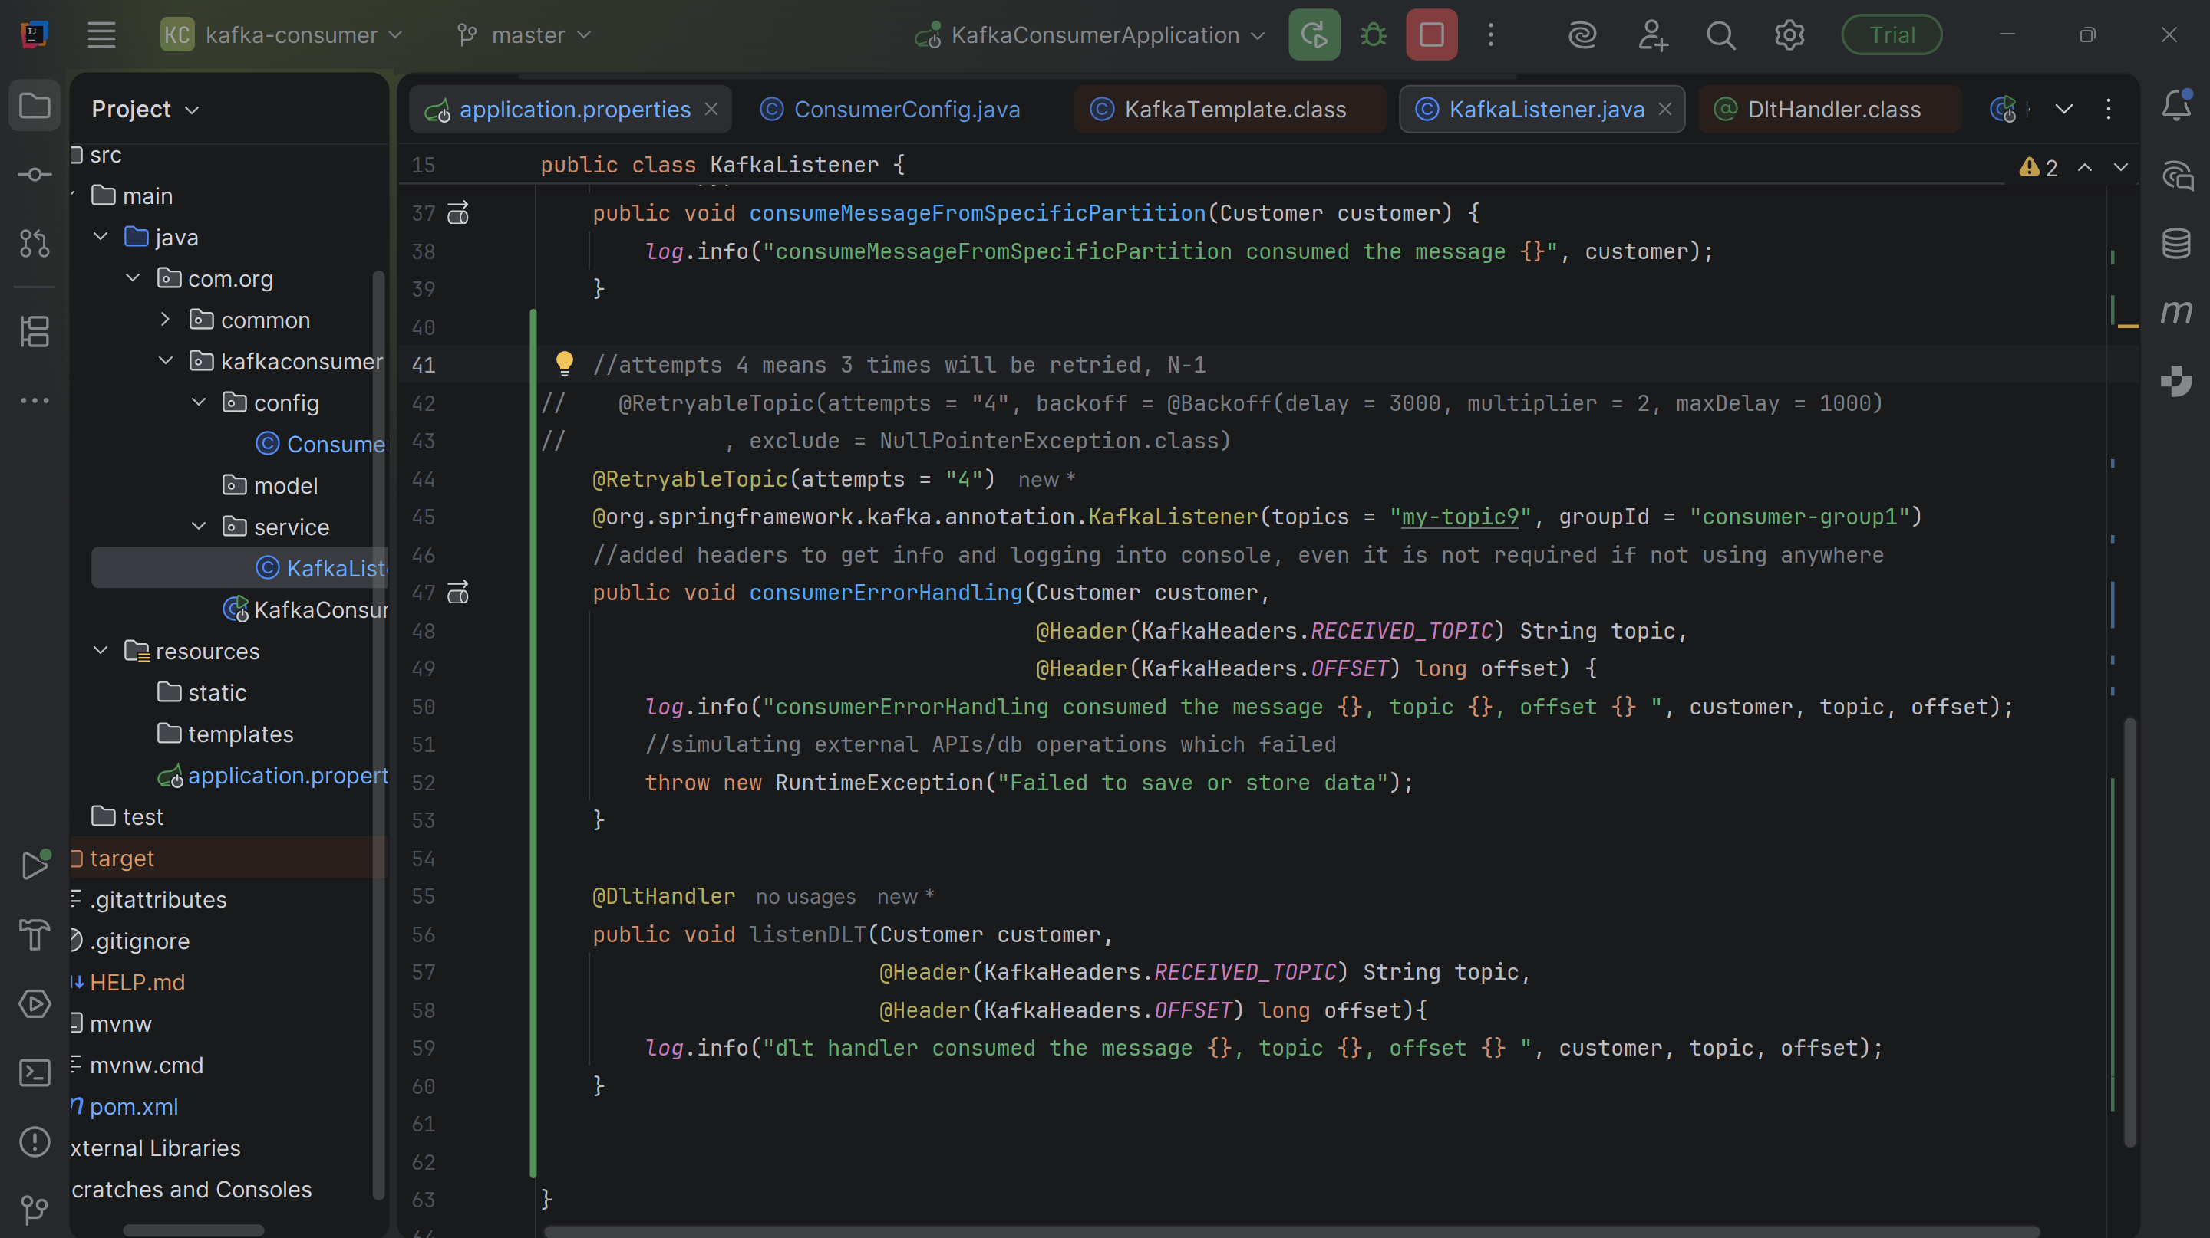

**Kafka Avro – Schema Registry:**

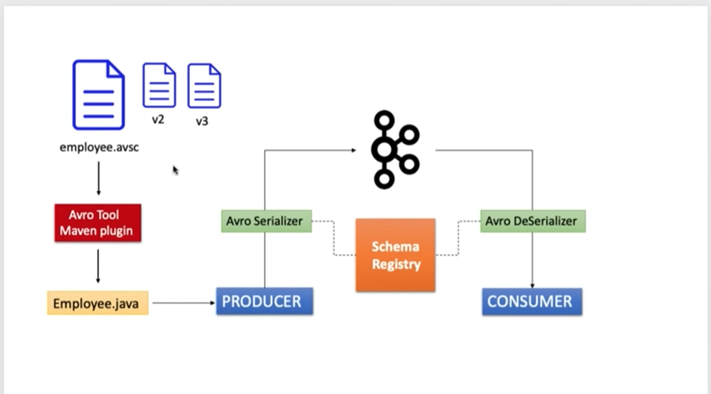

**Adding avro dependency:**

**<dependency>**

**<groupId>io.confluent</groupId>**

**<artifactId>kafka-avro-serializer</artifactId>**

**<version>7.4.0</version>**

**</dependency>**

**<dependency>**

**<groupId>io.confluent</groupId>**

**<artifactId>kafka-schema-registry-client</artifactId>**

**<version>7.4.0</version>**

**</dependency>**

**<dependency>**

**<groupId>org.apache.avro</groupId>**

**<artifactId>avro</artifactId>**

**<version>1.11.0</version>**

**</dependency>**

**And avro maven plugin as:**

**<plugin>**

**<groupId>org.apache.avro</groupId>**

**<artifactId>avro-maven-plugin</artifactId>**

**<version>1.8.2</version>**

**<executions>**

**<execution>**

**<id>schemas</id>**

**<phase>generate-sources</phase>**

**<goals>**

**<goal>schema</goal>**

**</goals>**

**<configuration>**

**<sourceDirectory>${project.basedir}/src/main/resources/</sourceDirectory>**

**<outputDirectory>${project.basedir}/src/main/java/</outputDirectory>**

**</configuration>**

**</execution>**

**</executions>**

**</plugin>**

**And take dependency from confluent repository:**

|  |
| --- |
| **<repositories>**  **<repository>**  **<id>confluent</id>**  **<url>https://packages.confluent.io/maven/</url>**  **</repository>**  **</repositories>** |

**Creating avro schema with extension .avsc that includes java package name fields included and the model object name.**

**Mvn build will create a autogenerated class in dto package with Employee class from schema.**

|  |
| --- |
| **{  "namespace": "com.org.kafkaschemaregistry.dto",  "type": "record",  "name": "Employee",  "fields": [  {  "name": "id",  "type": "string"  },  {  "name": "email",  "type": "string",  "default": null  },  {  "name": "age",  "type": "int"  }  ] }** |

**Using avro serializer and deserializer:**

spring.kafka.producer.value-serializer=io.confluent.kafka.serializers.KafkaAvroSerializer

spring.kafka.consumer.value-deserializer=io.confluent.kafka.serializers.KafkaAvroDeserializer

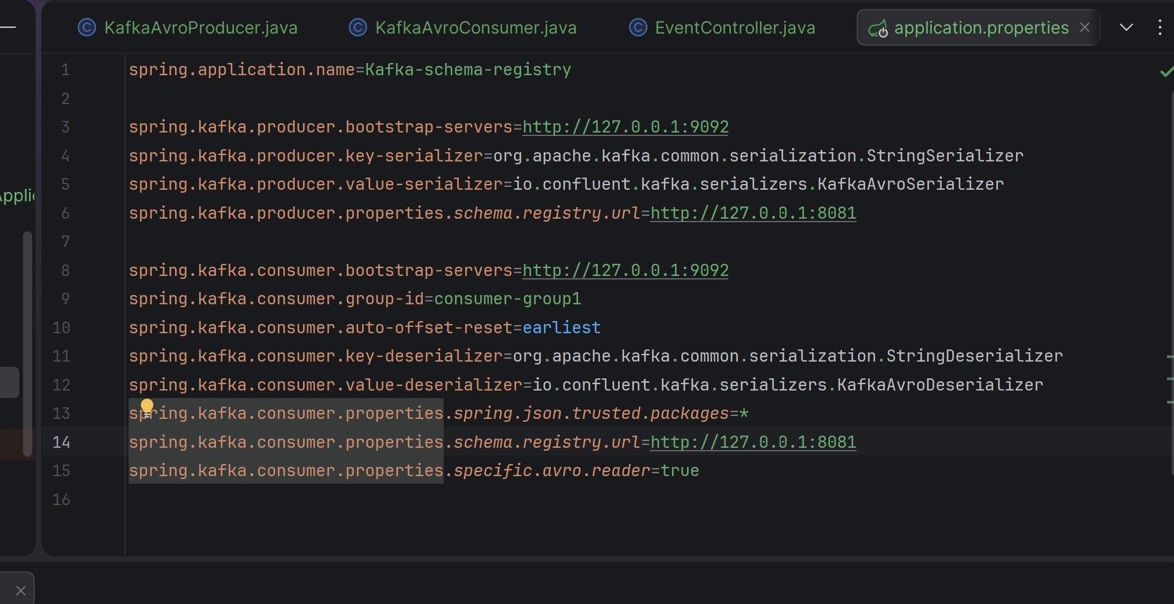

**Initial schema registered when message is published:**

**Control center screenshot for monitoring.**

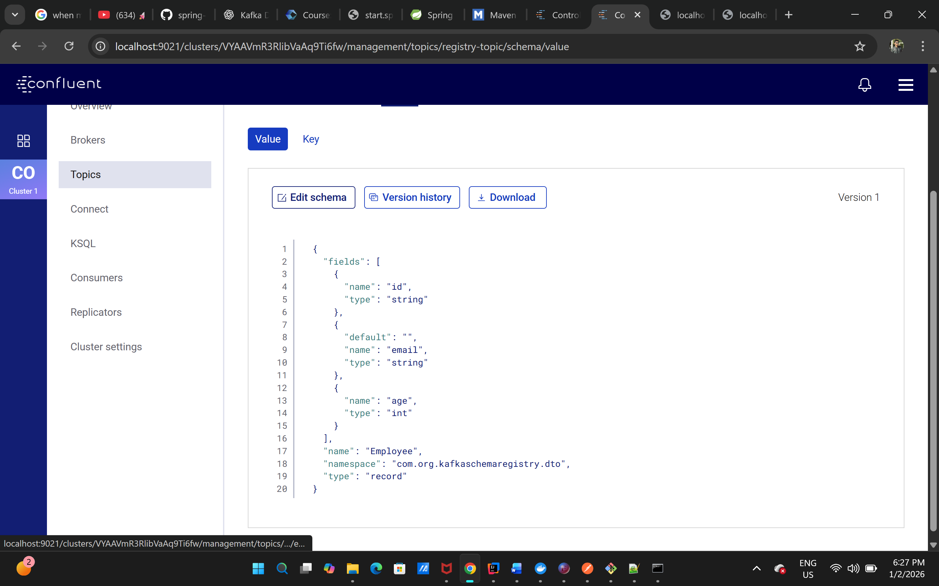

**Schema registry:**

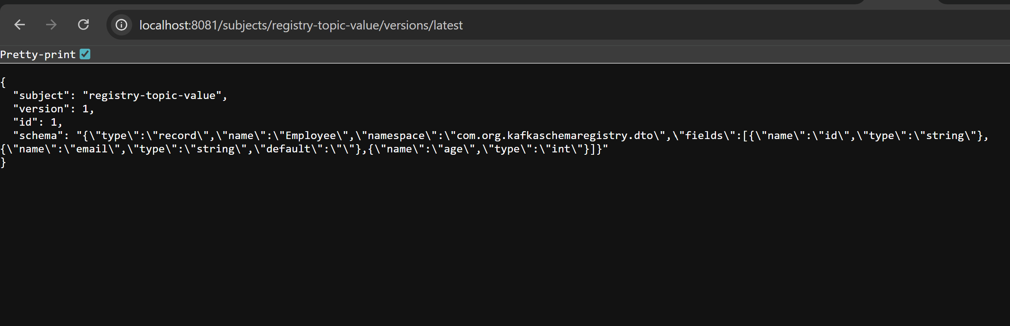

**Added new key name in schema.**

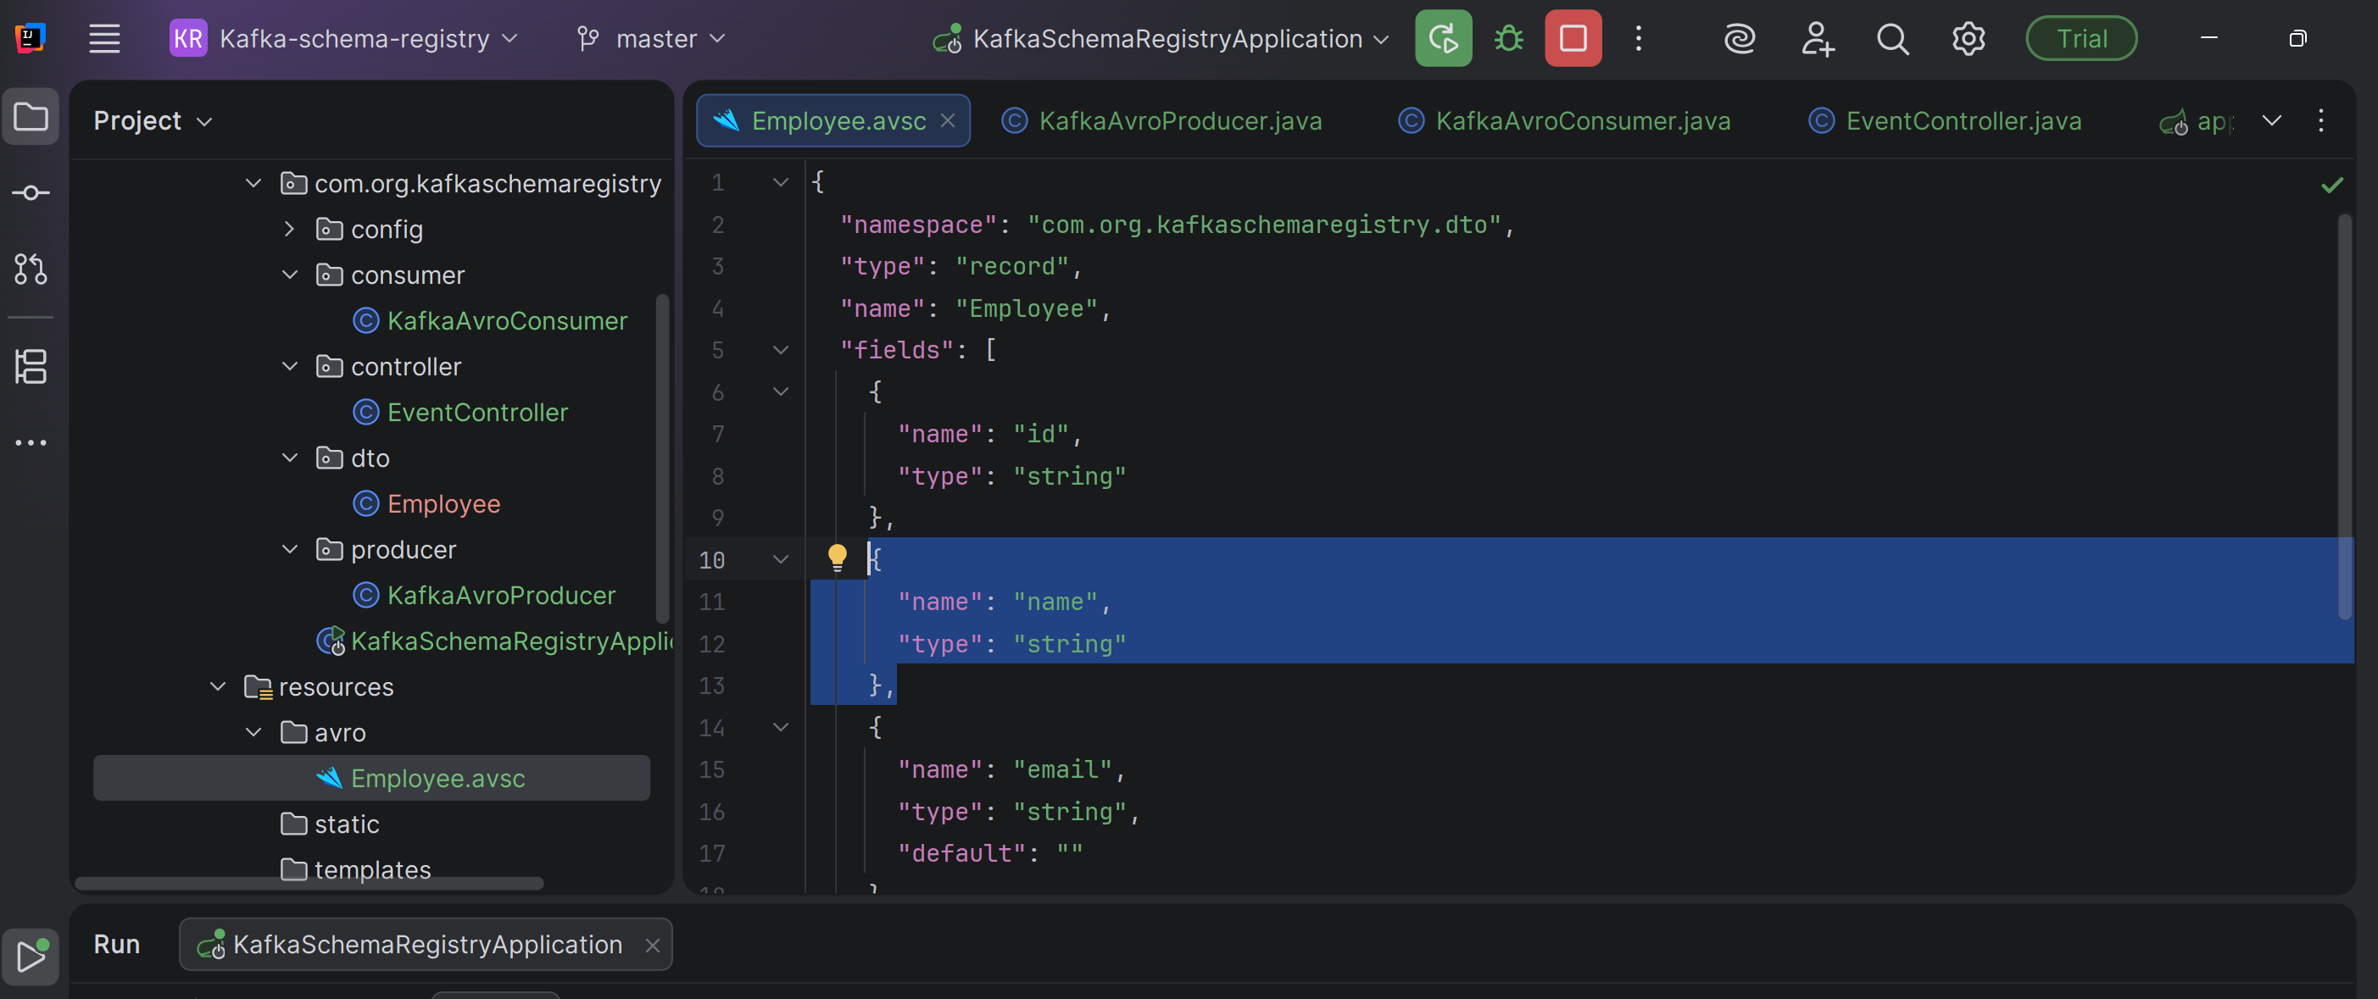

**Got an error : here Compatibility is checked when the producer tries to register a new schema for a subject:**

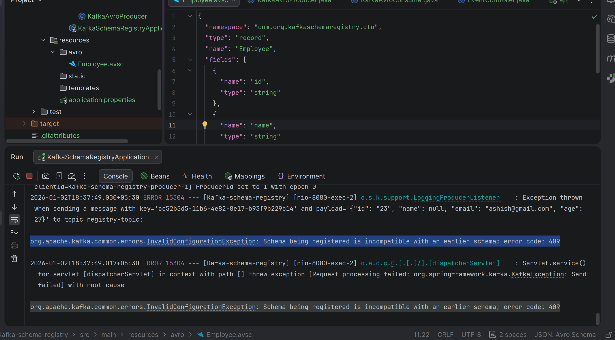

**Solution is to give default value as:**

**{  
 "name": "name",  
 "type": "string",  
 "default": ""  
}**

**A new version of schema is registered when message is published with new schema.**

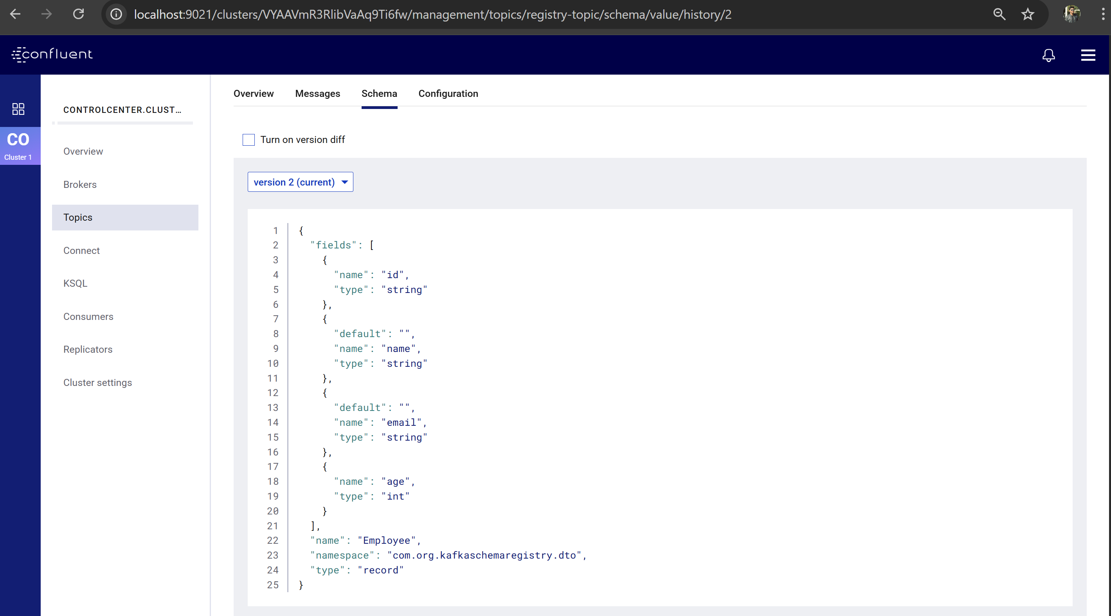

**Also, can check difference from previous schema.**

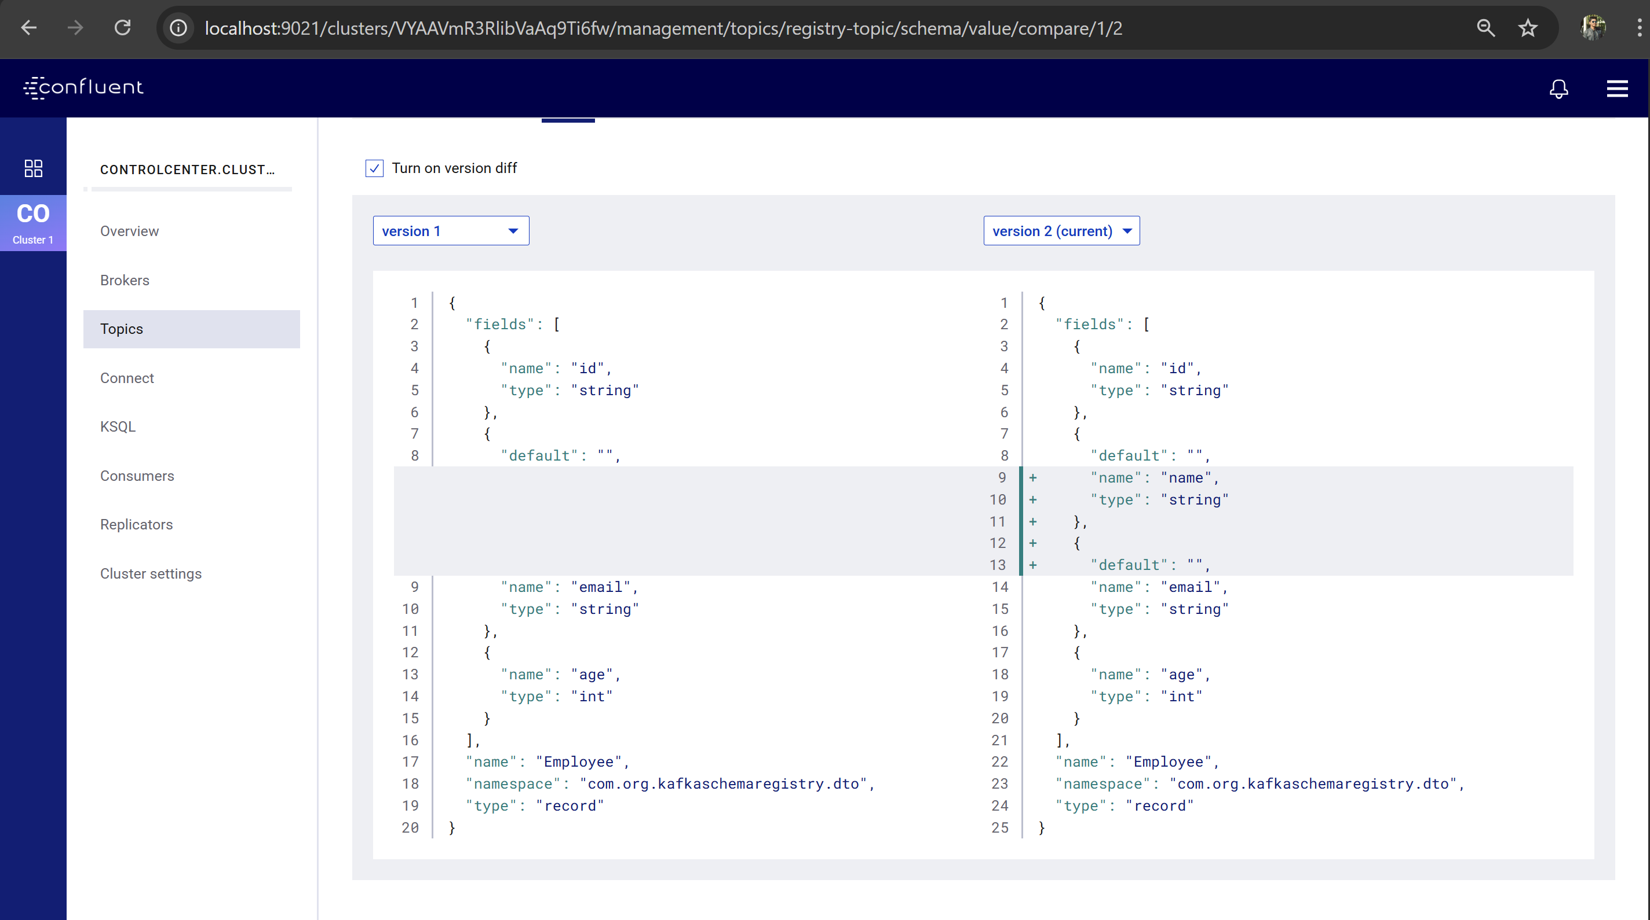

**Schema registry also updated:**

